VIVEKANAND EDUCATION SOCIETY’S INSTITUTE OF TECHNOLOGY
(An Autonomous Institute Affiliated to University of Mumbai)
Department of Computer Engineering


Project Report on

StockSense AI: Your Personal Investment Strategist

In partial fulfilment of the Fourth Year, Bachelor of Engineering (B.E.) Degree in Computer Engineering at the University of Mumbai
Academic Year 2025 - 26

By

Puneet Singh Kewalramani (D17A - 36)
Chetan Narang (D17C - 45)
Manit Khira (D17B - 22)
Vivek Menghani (D17B - 71)

Project Mentor
Mrs. Pallavi Saindane

(A.Y. 2025 - 26)

VIVEKANAND EDUCATION SOCIETY’S INSTITUTE OF TECHNOLOGY
(An Autonomous Institute Affiliated to University of Mumbai)
Department of Computer Engineering



Certificate

This is to certify that Puneet Singh Kewalramani (D17A - 36) of Fourth Year Computer Engineering studying under the University of Mumbai have satisfactorily completed the project on “StockSense AI: Your Personal Investment Strategist” as a part of their coursework of PROJECT - II for Semester - VIII under the guidance of their mentor Mrs. Pallavi Saindane in the year 2025 - 26.

This thesis/dissertation/project report entitled “StockSense AI: Your Personal Investment Strategist” by Puneet Singh Kewalramani is approved for the degree of Bachelor of Engineering in Computer Engineering.

Programme Outcomes | Grade
PO1, PO2, PO3, PO4, PO5, PO6, PO7, PO8, PO9, PO10, PO11, PO12 PSO1 & PSO2

Date:
Project Guide: Mrs. Pallavi Saindane

Project Report Approval
For
B. E (Computer Engineering)

This project report entitled “StockSense AI: Your Personal Investment Strategist” by Puneet Singh Kewalramani (D17A - 36), Chetan Narang (D17C - 45), Manit Khira (D17B - 22), Vivek Menghani (D17B - 71) is approved for the degree of Bachelor of Engineering in Computer Engineering.

Examiners

1. .......................................................
(Internal Examiner name & sign)

2. .........................................................
(External Examiner name & sign)

3. ........................................................
(Head of Department)

4. ........................................................
(Principal)

Date: ______________________
Place: Chembur, Mumbai

Declaration

We declare that this written submission represents our ideas in our own words and where others’ ideas or words have been included, we have adequately cited and referenced the original sources. We also declare that we have adhered to all principles of academic honesty and integrity and have not misrepresented or fabricated or falsified any idea/data/fact/source in our submission. We understand that any violation of the above will be cause for disciplinary action by the Institute and can also evoke penal action from the sources which have thus not been properly cited or from whom proper permission has not been taken when needed.

---------------------------------------  (Signature)  ---------------------------------------  Puneet Singh Kewalramani (D17A / 36) | ---------------------------------------  (Signature)  ---------------------------------------  Chetan Narang (D17C / 45)
---------------------------------------  (Signature)  ---------------------------------------  Manit Khira(D17B / 22) | ---------------------------------------  (Signature)  ---------------------------------------  Vivek Menghani (D17B / 71)

Date:

Acknowledgement

We are thankful to our college Vivekanand Education Society’s Institute of Technology for considering our project and extending help at all stages needed during our work of collecting information regarding the project.

It gives us immense pleasure to express our deep and sincere gratitude to Assistant Professor Mrs. Pallavi Saindane (Project Guide) for her kind help and valuable advice during the development of project synopsis and for her guidance and suggestions.

We are deeply indebted to Head of the Computer Department Dr. (Mrs.) Nupur Giri and our Principal Dr. (Mrs.) J.M. Nair, for giving us this valuable opportunity to do this project.

We express our hearty thanks to them for their assistance without which it would have been difficult in finishing this project synopsis and project review successfully.

We convey our deep sense of gratitude to all teaching and non-teaching staff for their constant encouragement, support and selfless help throughout the project work. It is a great pleasure to acknowledge the help and suggestion, which we received from the Department of Computer Engineering.

We wish to express our profound thanks to all those who helped us in gathering information about the project. Our families too have provided moral support and encouragement at several times.

Computer Engineering Department

COURSE OUTCOMES FOR B.E PROJECT

Learners will be to,

Course Outcome | Description of the Course Outcome
CO 1 | Able to apply the relevant engineering concepts, knowledge and skills towards the project.
CO2 | Able to identify, formulate and interpret the various relevant research papers and to determine the problem.
CO 3 | Able to apply the engineering concepts towards designing solutions for the problem.
CO 4 | Able to interpret the data and datasets to be utilized.
CO 5 | Able to create, select and apply appropriate technologies, techniques, resources and tools for the project.
CO 6 | Able to apply ethical, professional policies and principles towards societal, environmental, safety and cultural benefit.
CO 7 | Able to function effectively as an individual and as a member of a team, allocating roles with clear lines of responsibility and accountability.
CO 8 | Able to write effective reports, design documents and make effective presentations.
CO 9 | Able to apply engineering and management principles to the project as a team member.
CO 10 | Able to apply the project domain knowledge to sharpen one’s competency.
CO 11 | Able to develop a professional, presentational, balanced and structured approach towards project development.
CO 12 | Able to adopt skills, languages, environment and platforms for creating innovative solutions for the project.

Index

Chapter No. | Title | Page Number
Chapter 1 | Introduction | 1
1.1 | Introduction to the Project | 1
1.2 | Motivation for the Project | 2
1.3 | Problem Definition | 2
1.4 | Relevance of the Project | 3
1.5 | Methodology Used | 3
Chapter 2 | Literature Survey | 5
2.1 | Research Papers Referred | 5
2.2 | Books / Journals / Articles Referred | 7
2.3 | Interactions with Domain Experts | 8
2.4 | Existing Systems | 8
2.5 | Lacuna in Existing Systems | 9
2.6 | Comparison of Existing Systems and Proposed Work | 9
Chapter 3 | Requirements for the Proposed System | 10
3.1 | Functional Requirements | 10
3.2 | Non-Functional Requirements | 11
3.3 | Constraints | 11
3.4 | Hardware & Software Requirements | 11
3.5 | Techniques Utilized | 12
3.6 | Tools Utilized | 12
3.7 | Project Proposal | 13
Chapter 4 | Proposed Design | 14
4.1 | System Architecture | 14
4.2 | Block Diagram | 15
4.3 | Flow Design | 16
4.4 | Algorithms Utilized | 17
Chapter 5 | Methodology and Implementation of the System | 18
5.1 | Data Infrastructure | 18
5.2 | Central Dashboard and Navigation | 19
5.3 | Strategy Lab and Backtesting Engine | 28
5.4 | Firebase Authentication & User Management | 31
5.5 | Portfolio Personalization Module (PPM) | 32
Chapter 6 | Results and Discussion | 35
6.1 | Strategy Backtesting Results | 35
6.2 | Machine Learning Model Evaluation | 37
6.3 | Portfolio Optimization Results | 38
Chapter 7 | Conclusion and Future Scope | 39
7.1 | Conclusion | 39
7.2 | Future Scope | 39
Chapter 8 | References | 41
Chapter 9 | Appendix | 43

List of Figures

Fig. No. | Figure Title | Page No.
4.1 | Three-Tier System Architecture of StockSense AI | 14
4.2 | Block Diagram | 15
4.3 | Operational Flowchart of StockSense AI | 16
5.1 | Sample JSON-like Structure of Stock Data Retrieved using yfinance API | 18
5.2 | Sample Company Metadata Retrieved using yfinance (Dictionary Representation) | 19
5.3 | Sample Historical Time-Series Data in Pandas Dataframe Format | 19
5.4 | Beginner Friendly Videos Section to get new users to understand stock market basics | 20
5.5 | Sector selection dashboard | 20
5.6 | Stock selection interface IT sector | 21
5.7 | Real-time intraday price view | 21
5.8 | Historical OHLCV candlestick chart | 22
5.9 | SMA Crossover strategy visualization | 23
5.10 | SMA Crossover Buy and Sell | 23
5.11 | RSI strategy visualization | 24
5.12 | RSI Buy and Sell | 25
5.13 | MACD strategy visualization | 26
5.14 | Bollinger Bands strategy visualization | 27
5.15 | Bollinger Bands Buy and Sell | 27
5.16 | Side-by-side strategy comparison | 28
5.17 | Historical Data Filter | 29
5.18 | Strategy selection and education panel | 29
5.19 | Strategy Theory and Concepts with Parameter Configuration | 30
5.20 | Strategy Analysis & Backtesting Chart (6 months data) | 30
5.21 | Strategy performance vs. Buy & Hold benchmark | 31
5.22 | Risk profiling dashboard | 32
5.23 | Risk-adjusted portfolio allocation pie chart for the user’s risk profile | 33
5.24 | Portfolio weight table and sector distribution | 33

List of Tables

Table No. | Table Title | Page No.
2.1 | Comparison of Existing Financial Platforms with StockSense AI | 9
6.1 | Individual Indicator Backtesting Performance vs. Buy & Hold Benchmark | 35
6.2 | Aggregate Comparison of Indicators | 37
6.3 | Representative Portfolio Allocations for Different User Risk Profiles | 38
9.1 | List of Stocks (Large-Cap, Mid-Cap and Small-Cap | 43
9.2 | List of Abbreviations | 50

Abstract

Navigating the stock market presents a significant challenge for investors, particularly when selecting strategies and constructing portfolios suited to their financial profiles. Strategy effectiveness varies significantly across market segments and many investors lack the tools to validate them historically. As a result, investment decisions often rely on generalized advice rather than tailored, data-driven insights.
To address this, we propose StockSense AI, an intelligent advisory platform combining historical strategy analysis with machine learning–driven portfolio recommendations. The first component, the Strategy Lab, utilizes a backtesting engine to simulate how strategies would have performed across different stocks and time periods. This allows users to analyze risk-return characteristics and evaluate the practical viability of technical indicators like Simple Moving Average Crossover, Relative Strength Index, Bollinger Bands and Moving Average Convergence Divergence.
The second component, the Personalized Portfolio Manager (PPM), provides forward-looking decision support. Using machine learning models trained on historical indicators, the PPM predicts expected stock returns. It also incorporates a risk profiling model that evaluates user attributes such as age, income, investment corpus and risk tolerance to calculate an appropriate risk score. Based on these metrics, the platform optimizes and recommends personalized capital allocations from a curated stock universe.
The final output is presented through an interactive dashboard visualizing recommended allocations, sector distributions and projected growth. Built using Python and Streamlit, the platform seamlessly integrates real-time visualization, backtesting and ML-based forecasting. By combining strategy validation with personalized recommendations, StockSense AI successfully bridges the gap between theoretical investment strategies and practical, data-driven portfolio decision-making.

Chapter 1: Introduction
This chapter provides a comprehensive overview of the StockSense AI project, covering its conceptual foundation, the motivation behind its development and the specific problems it seeks to address. It outlines the relevance of the platform in the current financial technology landscape and describes the structured methodology adopted for its design and implementation.

1.1 Introduction to the Project
The Indian financial markets have witnessed unprecedented growth over the past decade, characterized by a massive surge in retail investor participation and digital trading adoption. Despite this rapid expansion in participation, the vast majority of retail investors navigate the complex landscape of equity markets without access to the sophisticated analytical tools routinely available to institutional investors, hedge funds and professional traders. The core challenge is not the availability of financial data which has become increasingly accessible through digital platforms but rather the ability to meaningfully interpret, validate and act upon this data using structured, evidence-based methodologies.
StockSense AI is conceived as a comprehensive, intelligent, web-based financial advisory platform that directly addresses this fundamental gap. The platform is built upon two deeply integrated and complementary components that together form a complete investment decision-support ecosystem. The first is the Strategy Lab, a rule-based analytical engine that enables users to historically validate trading strategies using four major technical indicators: Simple Moving Average (SMA) Crossover, Relative Strength Index (RSI), Moving Average Convergence Divergence (MACD) and Bollinger Bands. The second is the Portfolio Personalization Module (PPM), an AI-powered advisory engine built on a sophisticated dual-model architecture. It combines algorithmic risk profiling via a Random Forest Regressor, machine learning-based expected return forecasting using a Gradient Boosting Regressor and a Risk-Adjusted Allocation Engine to generate personalized, dynamically weighted investment portfolios.
Unlike existing platforms that either focus purely on trade execution or require substantial technical expertise for strategy backtesting, StockSense AI is designed to be simultaneously beginner-friendly and technically rigorous. By presenting complex financial analytics through an intuitive, highly interactive Streamlit-based web dashboard with real-time Plotly visualizations, the platform empowers users to make data-driven investment decisions without requiring any background in quantitative finance or programming. The system operates across three distinct market capitalization segments Large-Cap, Mid-Cap and Small-Cap stocks categorized by sector while user authentication and persistent risk profiles are securely managed through Firebase.

1.2 Motivation for the Project
The motivation behind StockSense AI stems from a persistent and well-documented information asymmetry in the Indian financial technology landscape. Institutional investors routinely employ quantitative analysts, proprietary algorithmic trading systems and sophisticated risk models to generate market-beating returns and dynamically rebalance portfolios. Retail investors, by contrast, are largely left with two inadequate alternatives: generic, one-size-fits-all advisory services that fail to account for individual risk profiles, or complex professional-grade tools that demand significant technical expertise.
This disparity is further compounded by the absence of unified platforms that combine strategy validation with portfolio management. Most available tools operate in silos, backtesting engines do not advise on portfolio allocation and portfolio advisors do not allow strategy validation. The result is a fragmented user experience that increases cognitive load and the potential for inconsistent, emotionally-driven decision-making.
StockSense AI is motivated by three core principles: first, the democratization of financial analytics applying tools previously restricted to institutional players through a no-code, visual interface; second, the promotion of data-driven decision-making grounding every recommendation in quantitative, historical evidence; and third, a commitment to financial literacy providing an interactive, educational environment where users develop genuine financial intuition over time.

1.3 Problem Definition
The current ecosystem of stock market advisory and analysis tools is characterized by several critical shortcomings that collectively hinder retail investors from making informed, evidence-based decisions.
- Generic, Non-Segmented Recommendations: Existing advisory systems provide blanket recommendations that fail to account for fundamental differences in risk, volatility and price behavior across Large-Cap, Mid-Cap and Small-Cap segments. A momentum-based strategy effective in volatile small-cap stocks may fail catastrophically if applied to large-cap blue-chip stocks.
- Inaccessible Backtesting Tools: Tools offering rigorous strategy backtesting require programming expertise that creates a prohibitive barrier for retail investors. No-code alternatives lack educational context and do not integrate AI-driven portfolio management.
- Limited Personalized Portfolio Management: Few widely accessible platforms combine individual risk profiling with machine learning-based return forecasting to generate personalized, risk-adjusted asset allocations tailored to a specific user’s financial profile.
- Static Visualizations: Available indicator charts are typically static and non-interactive. Users cannot adjust strategy parameters in real time, observe the direct financial impact, or perform side-by-side strategy comparisons under identical conditions.
- Fragmented Decision Support: The separation between technical analysis tools and portfolio management systems forces investors to operate across multiple disconnected platforms, increasing the risk of inconsistent investment decisions.
Problem Statement: To design, develop and deploy an intelligent, interactive, AI-powered financial advisory platform that enables retail investors to (a) construct, validate and evaluate trading strategies across different market capitalization segments through a comprehensive virtual capital backtesting engine and (b) receive personalized, risk-adjusted portfolio recommendations through a machine learning-driven portfolio optimization module, all accessible through a beginner-friendly interactive web dashboard.

1.4 Relevance of the Project
- Societal Impact (Financial Inclusion & Literacy): The platform acts as a practical tool for improving financial literacy by giving users an environment to understand how markets and strategies work. Instead of just theoretical knowledge, users can experiment with real data and see outcomes themselves. This aligns well with ongoing national efforts to promote financial awareness and responsible investing and also supports SDG 4 (Quality Education) and SDG 8 (Decent Work and Economic Growth).
- Technological Impact (Democratizing AI & Analytics): The project shows how machine learning can be effectively integrated into a simple and accessible web application. Models like Random Forest for risk estimation and Gradient Boosting for return prediction are used in a practical manner within a Streamlit interface. Along with this, a risk-adjusted allocation approach is applied to convert predictions into meaningful portfolio decisions.
- Economic Impact (Informed Decision Making): By enabling users to make decisions based on data rather than guesswork, the platform has the potential to improve individual investment outcomes. It helps in reducing losses caused by uninformed trading and encourages a more disciplined approach towards investing, which can contribute positively to overall market efficiency.

1.5 Methodology Used
- Data Acquisition & Interactive Charting: A curated universe of NSE-listed stocks is maintained across major sectors and market capitalization categories. Historical OHLCV data is dynamically fetched via the yfinance API and rigorously preprocessed using Pandas and NumPy. The complete web application is deployed via Streamlit, providing users with real-time, interactive Plotly visualizations and sector-based navigation.
- Strategy Implementation & Backtesting: Four core technical indicators SMA Crossover, RSI, MACD and Bollinger Bands are algorithmically encoded with configurable parameters. A deterministic backtesting engine simulates trades using virtual capital, computing Strategy Return, Success Rate and the Performance Gap, benchmarking directly against a passive Buy & Hold baseline.
- User Authentication & Profile Management: Acting as the secure gateway to the platform's advanced personalization features, Firebase handles user authentication and persistent profile storage. This ensures individual session states and financial data are securely maintained before entering the machine learning pipeline.
- Dual-Model Architecture: The system employs two distinct machine learning models. A Random Forest Regressor evaluates user demographics and financial inputs to categorize risk capacity (Normalized Risk Score). Simultaneously, a Gradient Boosting Regressor processes historical technical features to forecast standardized expected stock returns. Both models are rigorously evaluated using MAE and RMSE.
- Risk-Adjusted Portfolio Optimization: Rather than relying on standard black-box libraries, ML-predicted returns and historical volatility are processed through a custom Risk-Adjusted Allocation Engine using a modified Sharpe heuristic. The engine dynamically applies weighting constraints dictated by the user's specific risk category to generate an optimal, diversified portfolio.

Chapter 2: Literature Survey
This chapter presents a comprehensive review of existing academic research, commercial platforms and domain literature relevant to the design of StockSense AI. The survey covers machine learning approaches in financial forecasting, technical analysis methodologies, portfolio optimization frameworks and backtesting system design, culminating in an analysis of the gaps in existing systems that the proposed platform addresses.

2.1 Research Papers Referred

Z. Chen and J. Lee, “Enhancing Financial Trading Strategies using Transformer-based Deep Learning Models,” IEEE SSCI, 2024. [1]
Abstract: This paper investigates the application of Transformer-based deep learning architectures to financial trading strategy enhancement. By leveraging self-attention mechanisms, the model captures long-range temporal dependencies in financial time-series data that traditional recurrent models miss. The study demonstrates that Transformer models achieve superior performance in trend prediction and strategy signal generation compared to classical LSTM-based approaches.
Inference: While StockSense AI employs a Random Forest Regressor for portfolio prediction due to its lower computational overhead and superior interpretability in low-data regimes, this work highlights Transformer architectures as a compelling direction for future enhancement of the PPM’s prediction module.

Y. Wang, Q. Liu and J. Liang, “A Multi-Objective Deep Reinforcement Learning Framework for Algorithmic Trading,” IEEE TNNLS, 2024. [2]
Abstract: The paper proposes a multi-objective Deep Reinforcement Learning (DRL) framework that optimizes trading decisions by simultaneously balancing competing objectives: maximizing profit, minimizing risk and reducing transaction costs. The agent learns adaptive trading policies through repeated interaction with historical market data across varying market regimes.
Inference: This research validates the principle that different market conditions require dynamically adaptive strategies a core insight motivating StockSense AI’s segment-specific backtesting engine. The multi-objective evaluation framework also reinforces our approach of assessing strategies on returns, drawdown and win rate simultaneously.

H. Liu and J. Wu, “A Hybrid CNN-GRU Model with Attention Mechanism for Stock Market Trend Prediction,” IEEE Access, 2024. [3]
Abstract: This study introduces a hybrid deep learning architecture combining CNNs for local feature extraction and GRUs for sequential dependencies, augmented with an attention mechanism. The model outperforms standalone CNN, GRU and LSTM models on directional accuracy benchmarks across diverse stock markets.
Inference: The paper reinforces the importance of thorough data preprocessing and time-series feature engineering, which we implement in StockSense AI’s data pipeline using Pandas for OHLCV processing and technical indicator computation.

L. Yang, Z. Li and D. Wu, “Sector-Specific Stock Trend Prediction Using Graph Neural Networks,” IEEE Big Data, 2023. [4]
Abstract: This research models inter-company relationships within stock market sectors as a graph, applying GNNs with attention mechanisms to propagate sector-level information across connected stock nodes, demonstrating that sector context significantly enhances predictive performance.
Inference: This paper directly validates StockSense AI’s design decision to categorize and analyze stocks by both sector and market capitalization, confirming that strategy performance is fundamentally context-dependent across different market segments.

R. Kumar and S. S. Roy, “A Goal-Based Robo-Advising System using Deep Learning for Personalized Asset Allocation,” IEEE Access, 2024. [5]
Abstract: The paper presents a goal-based robo-advisor that uses deep learning models to generate personalized investment portfolios tailored to individual user profiles including age, income, risk tolerance and financial goals, dynamically adjusting allocations in response to changing conditions.
Inference: This work directly validates the design of StockSense AI’s PPM. The user profiling approach incorporating age, income and risk tolerance is central to our PPM’s risk scoring mechanism, confirming the academic soundness of our user-centric advisory approach.

A. Gupta and P. Singh, “An Event-Driven Backtesting Framework for High-Frequency Trading Strategies,” IEEE CASE, 2023. [6]
Abstract: The authors design a modular, event-driven backtesting system for evaluating high-frequency trading strategies. The framework separates signal generation from execution simulation, enabling accurate modeling of slippage, transaction costs and order book dynamics.
Inference: The modular, event-driven architectural principles separating data ingestion, signal generation, trade simulation and performance evaluation into distinct modules directly influenced our backtesting engine’s design. The multi-metric evaluation framework also informs our use of Win Rate, Maximum Drawdown and Net Returns.

F. Ahmad, “Machine Learning Models for Client Risk Profiling in Digital Wealth Management,” IEEE TEM, 2023. [7]
Abstract: This work investigates the application of supervised machine learning classifiers for automating client risk profiling in digital wealth management platforms, demonstrating significant improvements in profiling accuracy over traditional questionnaire-based approaches.
Inference: This paper validates StockSense AI’s risk profiling methodology, confirming that algorithmic approaches to risk classification produce more consistent results than manual assessments. Our Normalized Risk Score (0.0–1.0) mapping to Conservative/Balanced/Growth categories is directly inspired by this work.

J. Xu, C. Zhou and Y. Luo, “Meta Reinforcement Learning for Trading in Non-Stationary Financial Markets,” IASc, 2024. [8]
Abstract: The paper applies Model-Agnostic Meta-Learning (MAML) to financial trading, enabling trading agents to rapidly adapt to new, non-stationary market regimes by training a meta-learner across diverse market tasks.
Inference: This underscores that no single strategy performs uniformly across all market conditions a fundamental insight embedded in StockSense AI’s comparative framework. Our side-by-side strategy performance comparison helps users understand this principle empirically.

R. Wang, S. Li and H. Zhang, “Deep Reinforcement Learning for Stock Trading With Multi-Modal Features,” Expert Systems with Applications, 2024. [9]
Abstract: The authors integrate technical indicators, news sentiment data and raw price series into a multi-modal DRL framework, demonstrating that combining heterogeneous data modalities significantly enhances trading performance in volatile markets.
Inference: This reinforces the potential for expanding StockSense AI’s PPM in future iterations to incorporate multi-modal inputs such as news sentiment alongside technical features, enhancing predictive accuracy and improving portfolio recommendations.

2.2 Books / Journals / Articles Referred
- J. J. Murphy, Technical Analysis of the Financial Markets, New York Institute of Finance, 1999 [10]: Considered the foundational text for technical analysis, Murphy’s guide establishes the theoretical and mathematical basis for Moving Averages, RSI, MACD and Bollinger Bands implemented in StockSense AI.
- S. Nison, Japanese Candlestick Charting Techniques, 2nd ed., New York Institute of Finance, 2001 [11]: Informed the design of StockSense AI’s interactive price visualization module. The OHLCV candlestick charts rendered using Plotly follow display conventions established in this reference.
- M. Douglas, Trading in the Zone, Prentice Hall Press, 2000 [12]: Informed the educational design philosophy of StockSense AI. The emphasis on presenting clear, objective and evidence-based strategy outcomes is directly inspired by the principle that transparent feedback is essential for disciplined investment behavior.
- Yahoo Finance API (yfinance), 2024 [17]: Primary technical reference for implementing the data ingestion pipeline, covering OHLCV data retrieval, parameter configuration and data structure handling.
- Streamlit Documentation, 2024 [18]: Guided development of the multi-page web application including session state management, widget configuration, layout design and real-time data streaming.
- PyPortfolioOpt Documentation, 2024 [20]: Primary technical reference for implementing the Mean-Variance Optimization engine in the PPM, covering expected returns estimation, covariance matrix computation and efficient frontier calculation.

2.3 Interactions with Domain Experts
- Faculty Guidance: Regular mentorship sessions with project guide Mrs. Pallavi Saindane provided direction on system architecture, module design, machine learning model selection and academic documentation.
- Online Expert Resources: Insights were drawn from Zerodha Varsity, TradingView community educational content and the AlgoTrading India community’s documentation on strategy backtesting best practices.
- Technical Documentation: Expert-authored documentation from Scikit-learn and Firebase provided authoritative guidance for implementing the ML pipeline, portfolio optimization engine and user authentication system.

2.4 Existing Systems
- Zerodha (Kite Platform) [13]: India’s leading discount broker provides a clean trading interface with basic charting capabilities. Functions primarily as an execution platform with minimal support for strategy validation or educational backtesting.
- TradingView [14]: A globally popular charting platform offering professional-grade charts and a social trading community. Its backtesting functionality requires Pine Script knowledge, creating a significant barrier for non-technical retail investors.
- Streak [15]: A no-code backtesting platform integrated with Indian brokers. More accessible than TradingView for backtesting, but lacks an educational orientation, does not provide AI-driven portfolio advisory.
- Dhan [16]: An emerging trading platform with API access and analytical tools. Lacks a comprehensive learning-oriented backtesting module and portfolio personalization capabilities.

2.5 Lacuna in Existing Systems
- Beginner-Unfriendly Interfaces: Most platforms assume a baseline level of financial and technical expertise that excludes a large segment of retail investors.
- Limited Number of Integrated AI Advisory Systems: Few of the reviewed platforms successfully combine rule-based strategy backtesting with machine learning-based portfolio optimization within a single integrated interface.
- No Market Segmentation: Existing tools do not differentiate strategy performance across Large-Cap, Mid-Cap and Small-Cap segments, preventing users from appreciating the context-dependence of trading strategies.
- Lack of Personalization: No widely accessible platform tailors portfolio recommendations to an individual user’s age, income, risk appetite and investment horizon using quantitative methods.
- No Integrated Benchmarking: Few platforms automatically compare active strategy performance against a passive Buy & Hold benchmark, which is essential for objectively evaluating strategy efficacy.

2.6 Comparison of Existing Systems and Proposed Work
Feature | Zerodha [13] | TradingView [14] | Streak [15] | Dhan [16] | StockSense AI
Target Audience | All traders | Experienced | Tech-savvy | All traders | Beginner to Intermediate
Backtesting | Minimal | Pine Script | No-code | Limited | Interactive & Educational
AI Portfolio Advisory | None | None | None | None | ML + Risk-Adjusted Allocation
Market Segmentation | No | No | No | No | Yes (L/M/S Cap)
Risk Profiling | None | None | None | None | Algorithmic
Benchmark Comparison | No | Manual | Limited | No | Automatic
Table 2.1: Comparison of Existing Financial Platforms with StockSense AI

Chapter 3: Requirements for the Proposed System
This chapter outlines the comprehensive functional and non-functional requirements that define the scope and expected behavior of StockSense AI. It also describes the hardware and software environment, technical constraints and the tools and techniques employed in development.

3.1 Functional Requirements
- User Authentication & Profile Management: Secure user registration and login via Firebase Authentication. Each user’s risk profile and session history are persistently stored and retrieved across sessions.
- Stock Universe & Sector Navigation: A curated database of NSE-listed stocks categorized across eight sectors and three market capitalization tiers (Large-Cap, Mid-Cap, Small-Cap), enabling users to browse and select stocks for analysis.
- Real-Time & Historical Data Retrieval: Dynamically fetch real-time intraday and historical OHLCV data for any selected stock using the yfinance API, supporting multiple time period configurations (1M, 3M, 6M, 1Y, Max).
- Interactive Technical Indicator Computation: Compute and render four configurable technical indicators SMA Crossover, RSI, MACD and Bollinger Bands as interactive Plotly overlays on the price chart with user-adjustable parameters.
- Virtual Capital Backtesting Engine: Simulate trading strategies over historical data using virtual capital, generating Buy/Sell signals and computing key performance metrics including Total Return, Win-Rate, Performance Gap and Final Portfolio Value, along with comparison against a Buy & Hold benchmark.
- Side-by-Side Strategy Comparison: A comparative analytics view displaying performance metrics of all four technical indicators under identical market conditions for the selected stock and time period.
- Algorithmic Risk Profiling: Collect user inputs (age, income, investment corpus, investment horizon, risk appetite) and apply a heuristic scoring algorithm to compute a Normalized Risk Score (0.0–1.0), classifying users as Conservative, Balanced, or Growth.
- ML-Based Return Prediction: Use a trained Gradient Boosting Regressor to estimate expected future returns of stocks based on engineered financial features such as SMA, RSI, MACD, volatility and momentum, with performance evaluated using metrics like MAE and RMSE.
- Risk-Aware Portfolio Allocation: The system utilizes predicted asset returns generated by a machine learning model along with the investor’s risk profile to construct a personalized portfolio. Instead of applying traditional optimization techniques, a heuristic risk-adjusted allocation approach is used, where assets are evaluated based on their expected return and associated volatility. Portfolio weights are assigned in a manner that aligns with the user’s risk tolerance, ensuring a balance between return potential and risk exposure. The results are presented through intuitive visualizations such as allocation pie charts and detailed weight tables, enabling users to understand and interpret their investment strategy effectively.

3.2 Non-Functional Requirements
- Performance: A complete backtesting cycle for a single stock over a 1-year period shall complete within 10 seconds. The ML prediction and portfolio optimization pipeline shall produce results within 15 seconds.
- Usability: Operable by a user with no prior programming or quantitative finance knowledge. All strategy parameters are adjustable through intuitive sliders, dropdowns and input widgets with contextual explanations.
- Reliability: Target availability of 99.5% uptime. Graceful error handling implemented for API failures, insufficient data scenarios and invalid user inputs.
- Security: All user authentication managed through Firebase Authentication. No sensitive user financial data stored in plain text.
- Scalability: Modular architecture supports future addition of new indicators, asset classes and ML models without significant refactoring.

3.3 Constraints
- Python & Streamlit Framework: Built entirely in Python with Streamlit for rapid web application development with minimal frontend complexity.
- yfinance API Dependency: Market data sourced exclusively from Yahoo Finance via yfinance, which is free and reliable but introduces dependency on data availability and rate limits.
- NSE-Listed Stock Focus: The curated stock universe is restricted to NSE-listed Indian equities, providing specialized Indian market analysis.
- Daily Data Resolution: All backtesting performed at daily candle resolution, appropriate for swing and position trading but not intraday or high-frequency strategies.

3.4 Hardware & Software Requirements

Hardware Requirements
- Processor: Any modern multi-core processor (Intel Core i5 / AMD Ryzen 5 or equivalent)
- RAM: Minimum 8 GB (16 GB recommended for concurrent ML training and backtesting)
- Storage: Minimum 10 GB free disk space for Python environment and dependencies
- Network: Stable internet connection for real-time yfinance API data fetching

Software Requirements
- Operating System: Windows 10/11, macOS 12+, or Ubuntu 20.04+
- Python Environment: Python 3.9 or higher
- Key Libraries: Streamlit, yfinance, Pandas, NumPy, Scikit-learn, Plotly, Firebase Admin SDK
- Web Browser: Google Chrome, Mozilla Firefox, or Microsoft Edge (latest versions)
- Version Control: Git 2.x with GitHub for source code management

3.5 Techniques Utilized
- Technical Analysis: Mathematical computation of Simple Moving Average (SMA), Relative Strength Index (RSI), Moving Average Convergence Divergence (MACD) and Bollinger Bands from raw OHLCV data using established financial formulas, enabling rule-based signal generation for backtesting.
- Time-Series Analysis: Historical stock price data is processed using Pandas for rolling window calculations, feature engineering and sequential analysis of market trends.
- Ensemble Machine Learning: A Random Forest Regressor is used for risk estimation based on user attributes such as age, income, investment corpus, time horizon and risk appetite. The predicted risk score is further blended with user-provided risk preference to improve personalization and stability of classification.
- Return Prediction Model: A Gradient Boosting Regressor is trained on engineered financial features including SMA, RSI, MACD, volatility and momentum to estimate future returns over a defined horizon.
- Portfolio Allocation Strategy: Instead of traditional Mean-Variance Optimization, the system employs a heuristic risk-adjusted allocation approach. Assets are evaluated using predicted returns and associated volatility and portfolio weights are assigned in alignment with the user’s risk profile, ensuring a balance between expected return and risk exposure.

3.6 Tools Utilized
- Streamlit: Open-source Python framework for building the complete interactive web UI layer.
- yfinance: Python library for fetching historical and real-time market data from Yahoo Finance.
- Pandas & NumPy: Core data manipulation libraries for OHLCV data processing, indicator computation and feature engineering.
- Scikit-learn: Machine learning library used for implementing the Random Forest Regressor for risk prediction and the Gradient Boosting Regressor for stock return forecasting, along with model evaluation metrics.
- Plotly: Interactive graphing library for rendering candlestick charts, indicator overlays, equity curves and portfolio allocation pie charts.
- Firebase: Providing secure user authentication (Firebase Authentication) and persistent user profile storage (Firestore Database).
- Git & GitHub: Version control and hosting platform for source code management and project documentation.

3.7 Project Proposal
StockSense AI addresses a clear and significant gap in the retail financial technology landscape: the absence of a unified, accessible platform that combines historical strategy validation with AI-driven portfolio personalization. By integrating a rule-based backtesting engine with a machine learning-powered advisory module, all delivered through an intuitive no-code web interface, the platform enables pre-trade strategy validation, reduces decision-making uncertainty and provides personalized risk-adjusted investment guidance to India’s growing retail investor community.

Chapter 4: Proposed Design
This chapter presents the complete system design of StockSense AI, including the high-level system architecture, modular breakdown, detailed data flow diagrams and the operational workflow. Each design element is explained in detail with reference to the corresponding architectural diagram.

4.1 System Architecture
The architectural foundation of StockSense AI, illustrated in Figure 4.1, is a three-tier, multi-layered system designed for real-time financial analysis and intelligent portfolio management. The architecture enforces a clean separation of concerns across three primary layers, each with clearly defined responsibilities.
Data & Storage Layer: This main tier handles all external data interactions. Historical and near real-time intraday market data are fetched via the Yahoo Finance API (yfinance), with periodic updates, while user authentication credentials and risk profile data are securely managed through Firebase’s cloud infrastructure.
Application Layer: The core computational engine of the system. Raw data is processed using Pandas and NumPy before being routed through two distinct analytical pathways: the Strategy & Backtesting Engine for rule-based technical analysis and the AI Portfolio Personalization Module (PPM) for risk profiling, machine learning-based return prediction and risk-adjusted portfolio allocation.
Presentation Layer: Built on the Streamlit framework, this tier renders all processed data and analytical outputs as interactive and user-friendly visual dashboards using Plotly. It provides the complete user interface, including stock selection, strategy configuration, performance visualization and portfolio allocation display.

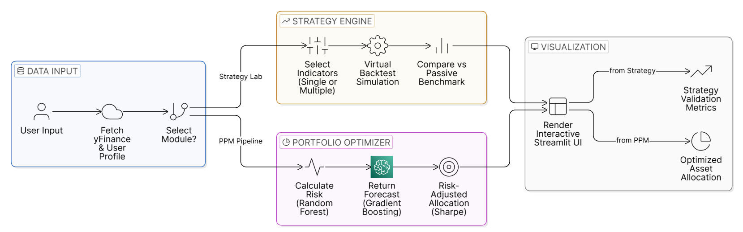
Fig. 4.1: Three-tier system architecture of StockSense AI

4.2 Block Diagram

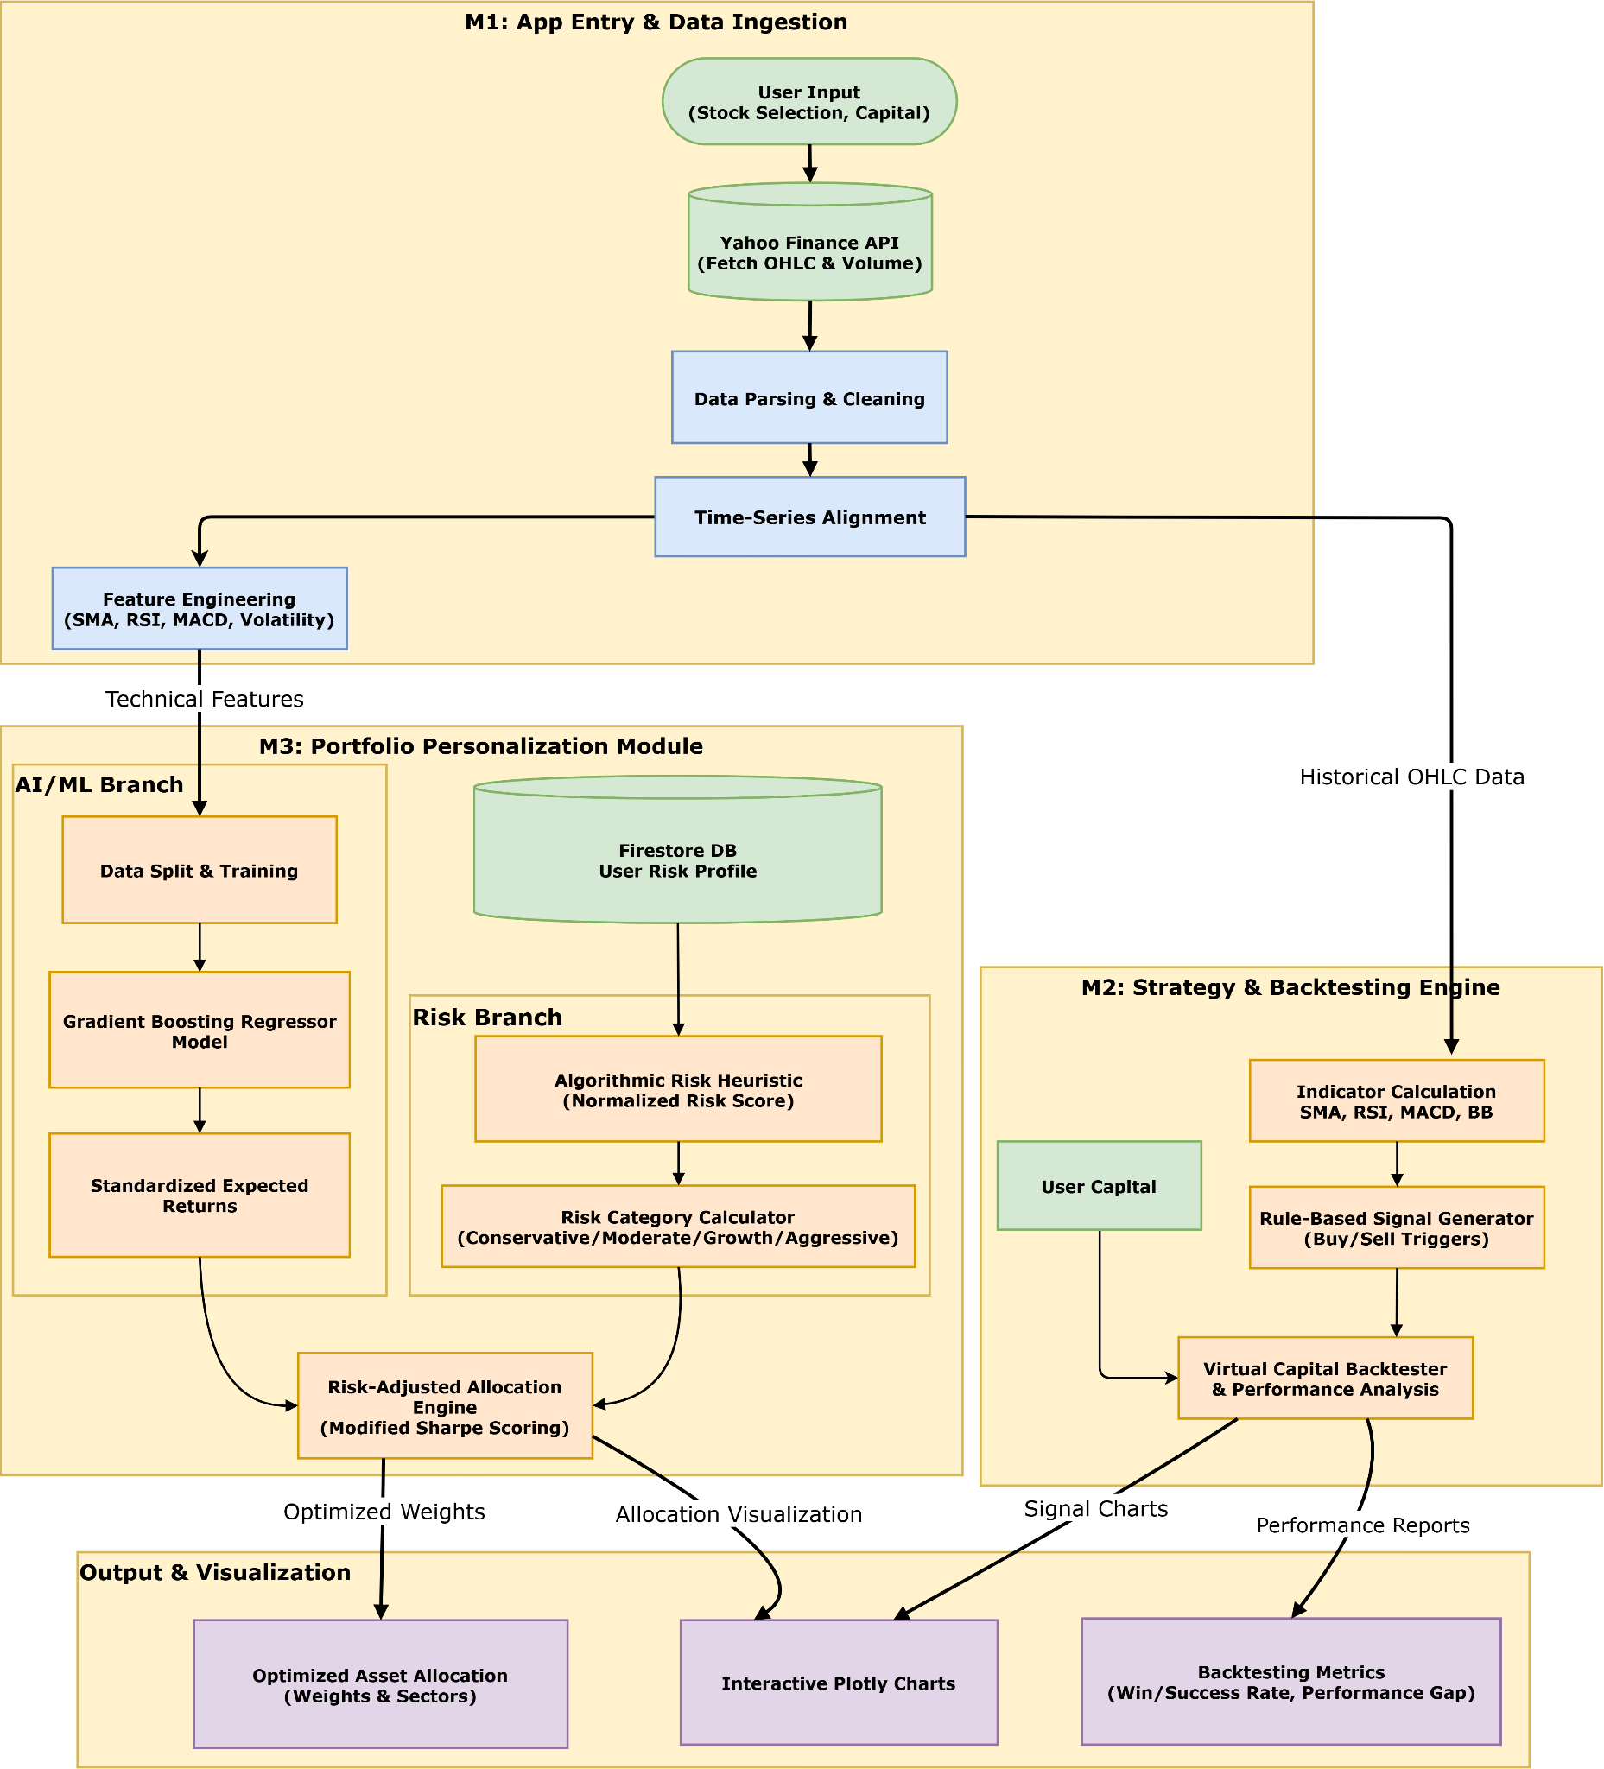
Fig. 4.2: Detailed block diagram of StockSense AI

Figure 4.2 illustrates the core operational pipeline of StockSense AI. User inputs trigger the Data Ingestion module to fetch OHLCV data via the yfinance API, which is subsequently cleaned and engineered. This processed data feeds two parallel operational engines: the Strategy & Backtesting Engine (handling isolated indicator computation, compound multi-indicator strategy synthesis and virtual capital simulation) and the Portfolio Personalization Module (PPM) Pipeline. Within the PPM, a Random Forest model computes risk capacity while a Gradient Boosting model predicts standardized expected returns, both of which drive a custom Risk-Adjusted Allocation Engine. All system outputs are visualized via interactive Plotly dashboards, with Firebase securely managing user authentication and profile persistence.

4.3 Flow Diagram

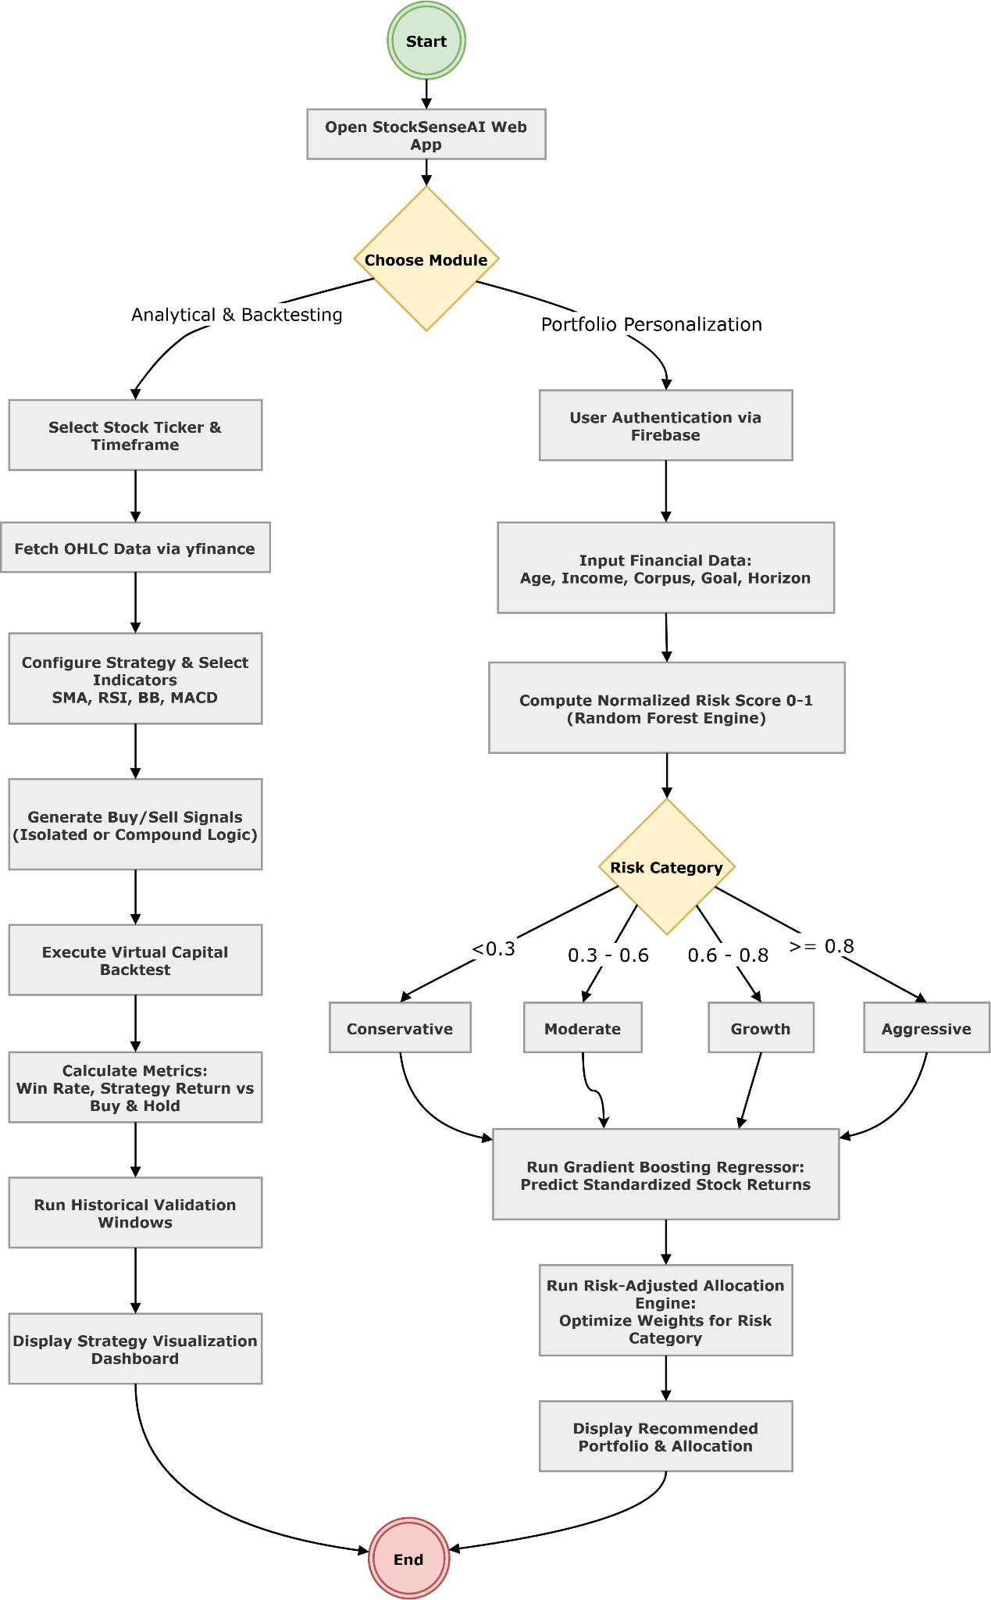
Fig. 4.3: Operational flowchart of StockSense AI

The detailed block diagram in Figure 4.3 illustrates the comprehensive data architecture of StockSense AI across all system layers. User inputs received via the User Interface are forwarded to the Application Core, where the Data Ingestion module retrieves raw OHLCV data and passes it to the Data Processing module for cleaning and technical feature engineering. The processed data stream then diverges into two primary pathways: the Strategy & Backtesting Engine, which computes technical indicators, synthesizes compound boolean logic via the Strategy Builder and executes virtual capital simulations; and the Portfolio Personalization Module (PPM), which employs a Random Forest Regressor for risk profiling and a Gradient Boosting Regressor for asset forecasting to drive a custom Risk-Adjusted Allocation Engine. Ultimately, all outputs from both functional pathways are rendered through the Visualization module as interactive Plotly dashboards, with Firebase managing secure user authentication and profile persistence throughout the session.

4.4 Algorithms Utilized

- Simple Moving Average (SMA) Crossover: Computes short-term and long-term SMAs. A bullish Buy signal is generated when the short-term SMA crosses above the long-term SMA (Golden Cross); a bearish Sell signal triggers on the reverse crossover (Death Cross).
- Relative Strength Index (RSI): Computes a normalized momentum oscillator from average upward and downward price changes over a configurable window. Buy signals are justified when the asset drops below the oversold threshold; Sell signals trigger above the overbought threshold.
- Moving Average Convergence Divergence (MACD): Computes the difference between EMA₁₂ and EMA₂₆ (MACD Line) alongside a 9-period EMA of the MACD Line (Signal Line). Algorithmic Buy and Sell signals are generated based on the directional crossovers of these two lines.
- Bollinger Bands: Constructs dynamic upper and lower price volatility envelopes calculated as the 20-period SMA ± k standard deviations. Buy signals are justified when the price strikes the lower support band; Sell signals trigger at the upper resistance band.
- Virtual Capital Backtesting Simulation: A deterministic event-driven engine that tracks all generated signals over a historical temporal window. It simulates transactions with fixed initial virtual capital to compute the Strategy Return, Success Rate, Final Portfolio Value and the net Performance Gap against a passive Buy & Hold baseline.
- Algorithmic Risk Profiling Engine (Random Forest): Applies a weighted mathematical heuristic to user demographic and financial inputs, which is then processed by a Random Forest Regressor to derive a Normalized Risk Score [0.0, 1.0]. This maps the user into a Conservative, Moderate, Growth, or Aggressive constraint category.
- Expected Returns Forecasting (Gradient Boosting): An ensemble machine learning model trained on historical stock features (including SMA, RSI, MACD and historical volatility) to predict standardized expected future yields, mitigating overfitting on noisy financial data through sequential residual error correction.
- Risk-Adjusted Allocation Engine: A proprietary algorithmic allocator that evaluates the predicted returns against historical volatility to compute a modified Sharpe score ($μ/σ+ϵ$). It applies dynamic, risk-dependent mathematical weighting constraints to identify the optimal fractional allocation for a given user profile.

Chapter 5: Methodology and Implementation of the System
This chapter describes the complete implementation of StockSense AI, detailing the technical methodology employed in the development of both modules. It covers the data ingestion pipeline, technical indicator computation, backtesting engine logic, risk profiling algorithm, machine learning prediction model, portfolio optimization engine and user authentication system, supported by annotated screenshots of the implemented platform.

5.1 Data Infrastructure:
The stock market data is retrieved using the yfinance Python library, which provides structured financial data in the form of Python objects. The raw company-level information is obtained as a dictionary-like structure (similar to JSON format), as shown in Figure 5.1, while detailed company metadata such as sector, industry and business summary is illustrated in Figure 5.2. Historical market data is returned as a Pandas DataFrame containing time-series OHLCV (Open, High, Low, Close, Volume) values, as shown in Figure 5.3. The yfinance library abstracts the underlying API calls and returns data in analysis-ready formats, eliminating the need for manual JSON parsing. This processed dataset is directly used for preprocessing, technical indicator computation and strategy backtesting within the system.

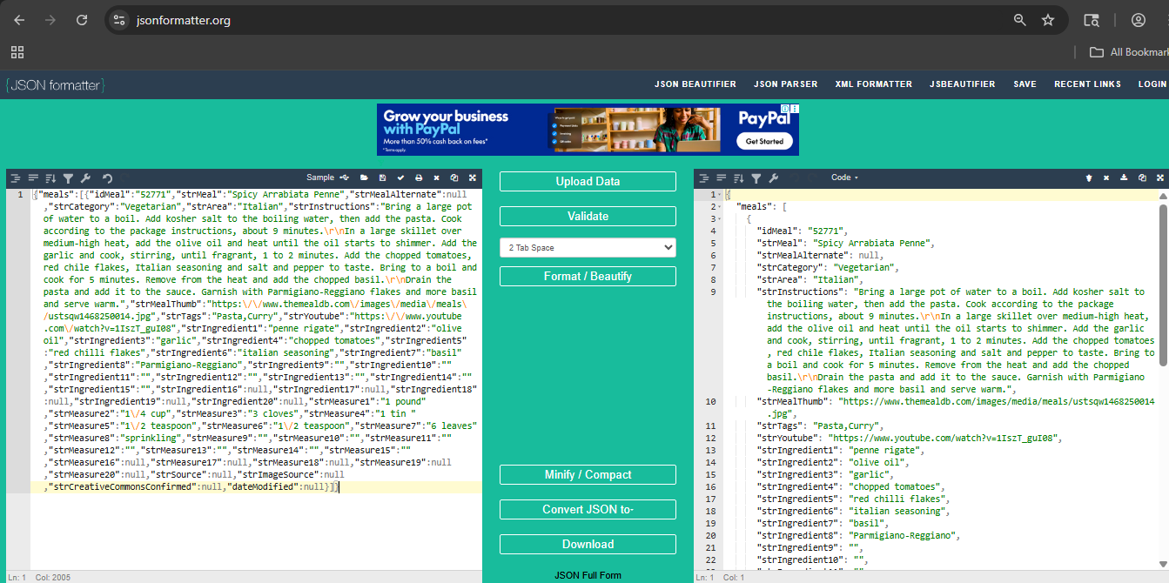
Fig. 5.1 Sample JSON-like Structure of Stock Data Retrieved using yfinance API

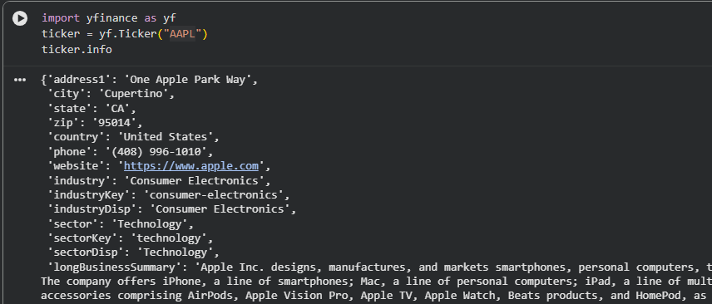
Fig. 5.2 Sample Company Metadata Retrieved using yfinance (Dictionary Representation)

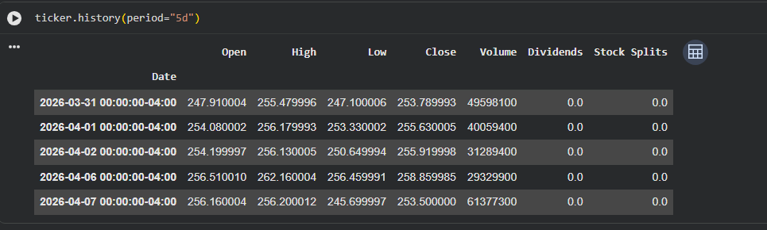
Fig. 5.3 Sample Historical Time-Series Data in Pandas Dataframe Format

5.2 Central Dashboard & Navigation
The User Module acts as the critical bridge between the complex backend analytical engines and the end-user. Because StockSense AI targets beginner to intermediate investors, presenting raw financial data or complex algorithmic outputs without context would lead to a poor user experience. The theoretical foundation of this module is based on minimizing cognitive load, transforming dense financial metrics into an interactive, visual and educational format.

5.2.1 Beginner Video Learning Hub & Onboarding
The operational flow begins with user onboarding and education. Before engaging with active trading strategies or risk profiling, users must understand foundational market mechanics. As shown in Figure 5.4, the dashboard opens with the Beginner Video Learning Hub, providing a curated prerequisite crash course. This ensures users grasp basic market terminology before attempting to allocate virtual capital.

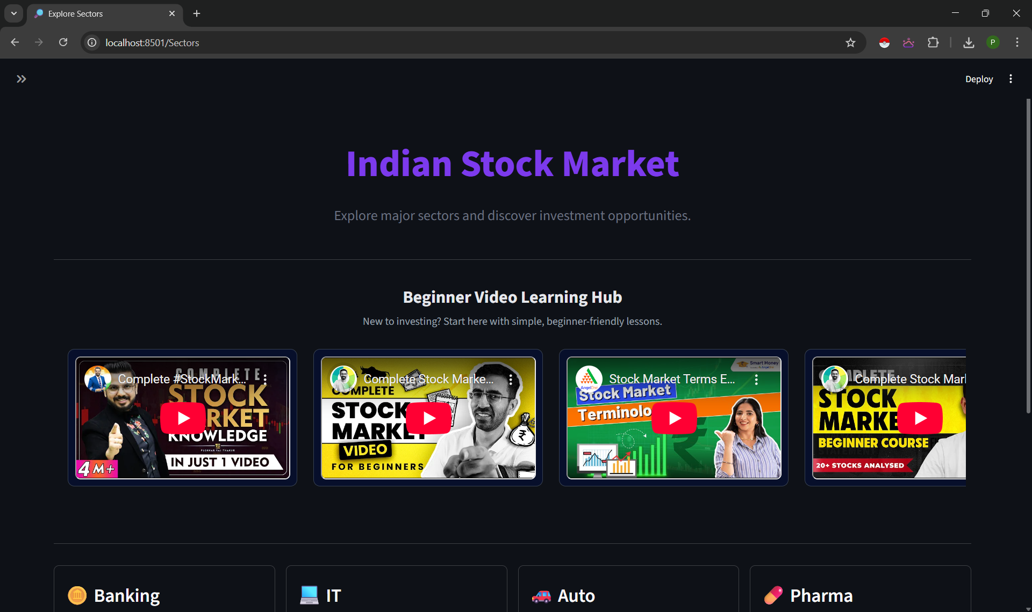

Fig. 5.4: Beginner Friendly Videos Section to get new users to understand stock market basics

5.2.2 Sector & Market Capitalization Navigation
To make the massive Indian Stock Market intuitive to navigate, the platform utilizes a top-down selection flow. First, users make a macro-level selection from the Sector Dashboard, illustrated in Figure 5.5, which categorizes the market into familiar industries such as Banking, IT, Auto, Pharma, FMCG, Energy, Metal and Realty. These selected sectors make it easier for users to navigate the complex Indian stock market without making it too overly difficult for them.

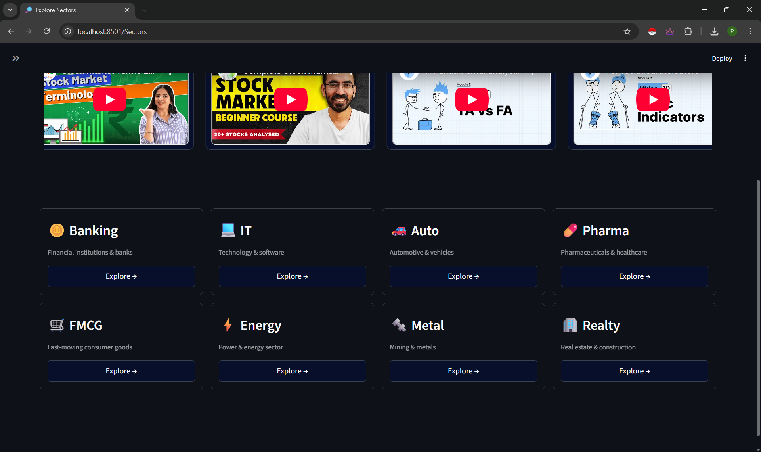
Fig. 5.5: Sector selection dashboard

Once a sector is selected, the platform further segments the equities to help users intuitively grasp the inherent risk associated with different companies. As illustrated in Figure 5.6 (using the IT Sector as an example), stocks are categorized into three distinct tiers:
- Large-Cap: Established, stable companies with lower risk but slower growth (e.g., TCS, Infosys).
- Mid-Cap: Growing companies that offer a balance of moderate risk and moderate return potential.
- Small-Cap: Highly volatile companies that carry high risk but offer the potential for massive relative returns.

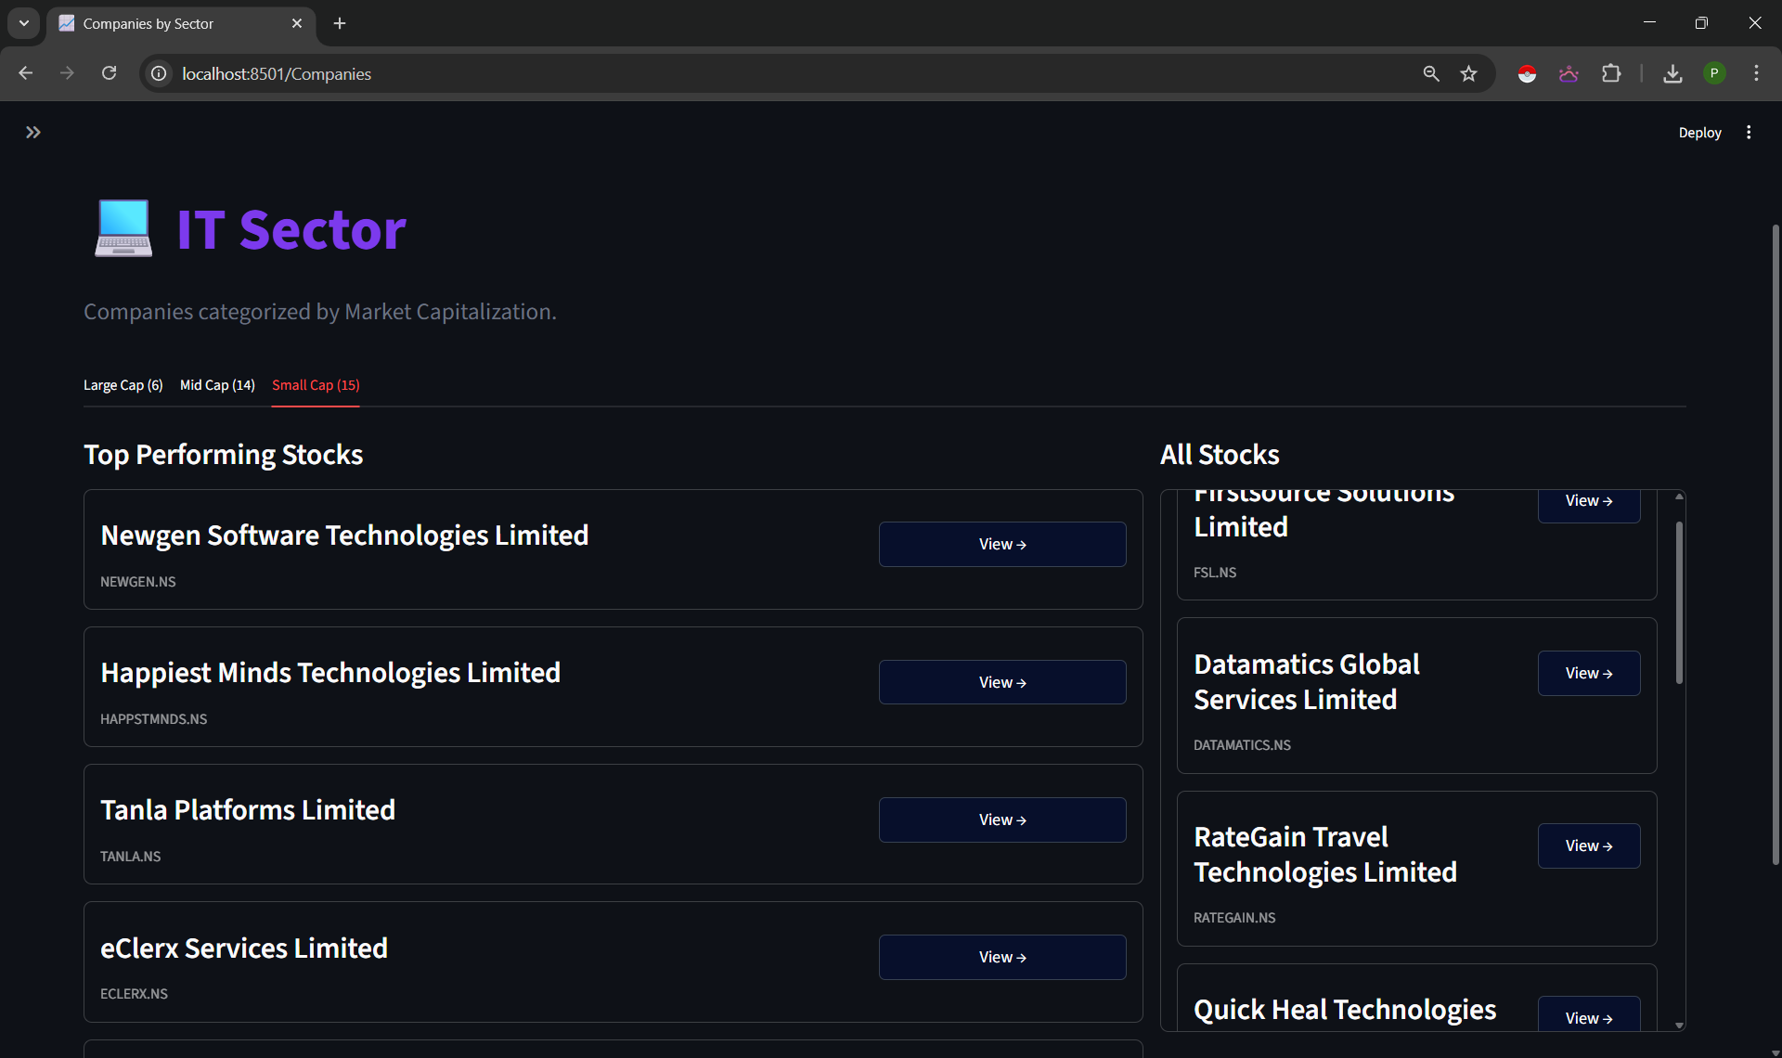
Fig. 5.6: Stock selection interface IT sector

5.2.3 Real-Time Intraday and Historical Price Charts
To facilitate technical analysis, the module replaces static data tables with dynamic visual representations. Upon selecting a specific asset, the user is presented with a Real-Time Intraday Price View, shown in Figure 5.7, which tracks short-term market movements. For macro-level trend identification, the platform renders an interactive Historical OHLCV (Open, High, Low, Close, Volume) candlestick chart, demonstrated in Figure 5.8, allowing users to adjust time horizons and analyze long-term price action.
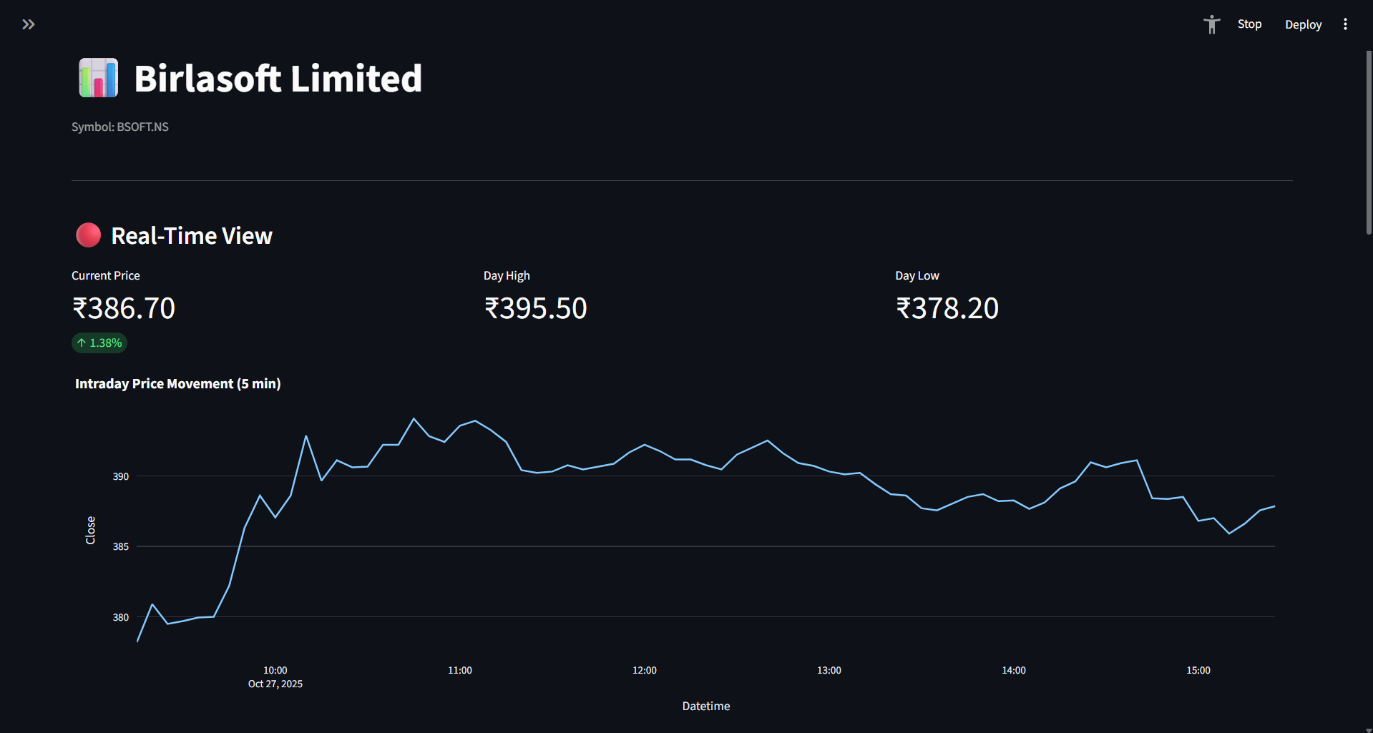
Fig. 5.7: Real-time intraday price view
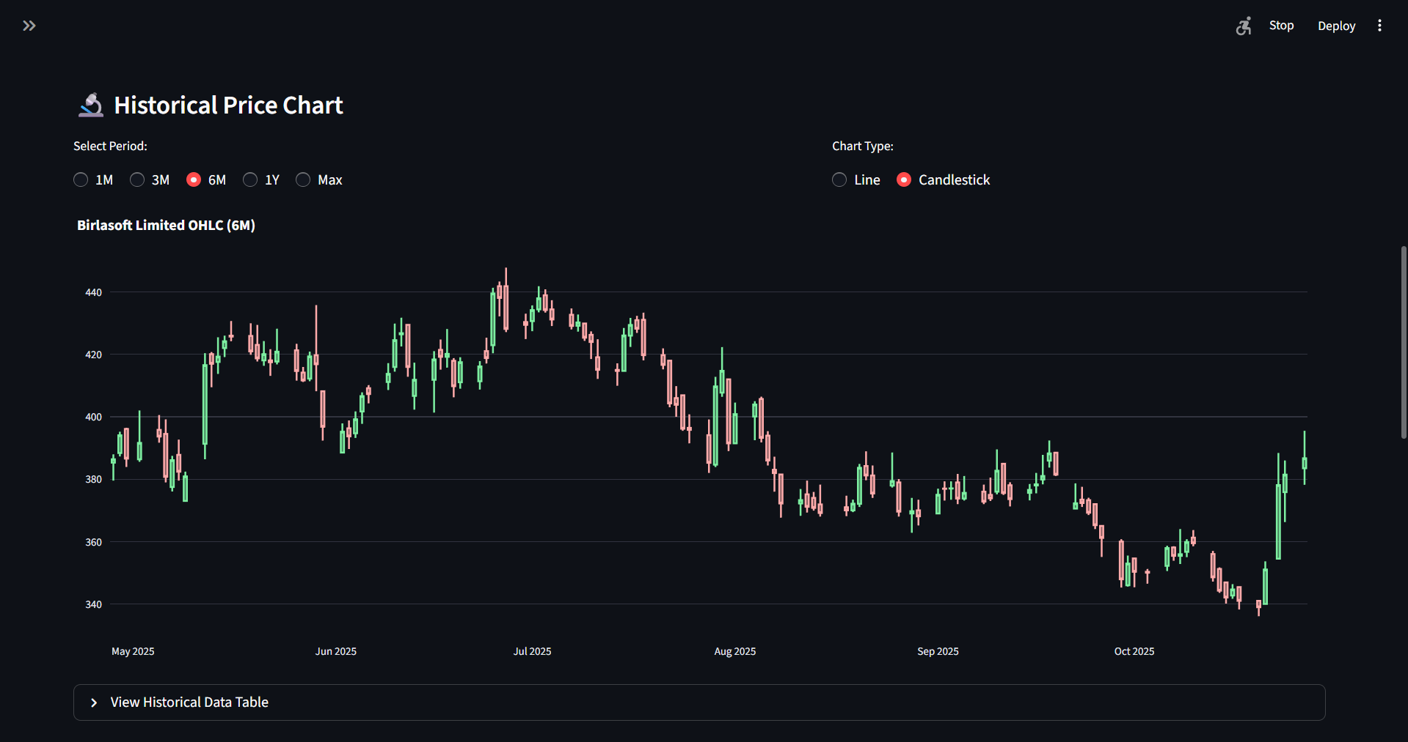
Fig. 5.8: Historical OHLCV candlestick chart

5.3 Strategy Lab & Backtesting Engine

5.3.1 Technical Indicator Implementation

A. Simple Moving Average (SMA) Crossover
Moving averages smooth short-term price fluctuations to highlight underlying trends. The SMA Crossover strategy computes two SMAs with configurable short-term (default: 20 periods) and long-term (default: 50 periods) windows:

SMAₙ = (1/N) × Σ Pᵢ (i = t-N+1 to t)

Where SMA_{n}: The Simple Moving Average calculated over N periods.
N : The specified time window or number of periods (e.g., 50 days, 200 days).
Σ: Sum of closing prices over N periods
P_{i}: Closing price at time i
t: Current time period

A bullish Buy signal triggers when the short-term SMA crosses above the long-term SMA (Golden Cross); a bearish Sell signal on the reverse (Death Cross).
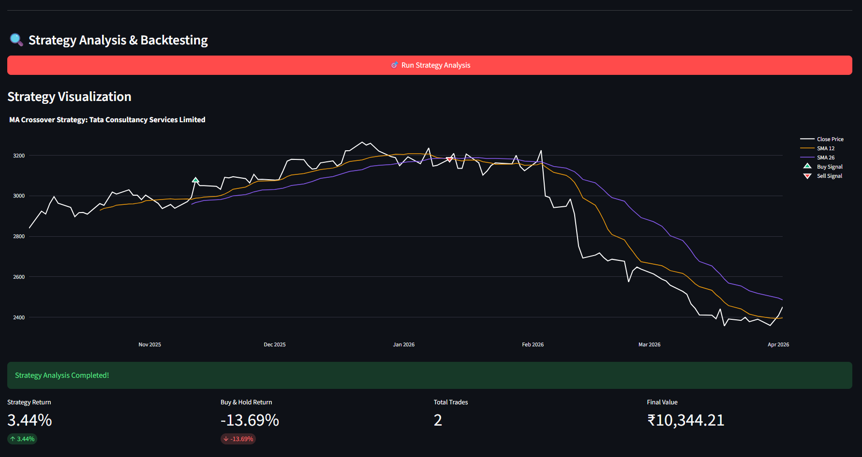
Fig. 5.9: SMA Crossover strategy visualization

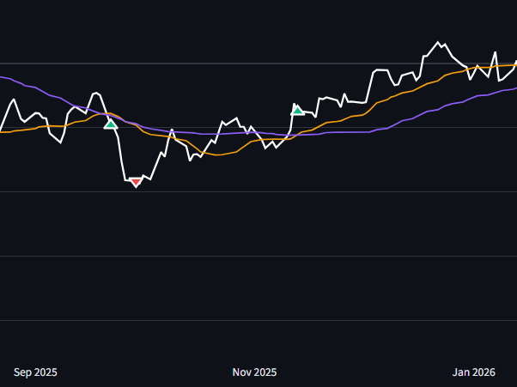
Fig. 5.10: SMA Crossover Buy and Sell

As illustrated in Figure 5.9, the Strategy Lab visually plots both the short-term and long-term moving averages directly onto the price chart. The system's algorithmic justification for generating trading signals, detailed further in Figure 5.10, relies on the intersection of these lines. A bullish "Buy" signal triggers when the short-term SMA crosses above the long-term SMA (known as a Golden Cross), indicating upward momentum. Conversely, a bearish "Sell" signal is generated when the short-term SMA crosses below the long-term SMA (a Death Cross).
Backtest Result (L1, 6 months): 2 trades yielding +3.44%, outperforming the -13.7% Buy & Hold benchmark by +17.1%, demonstrating the indicator’s effectiveness in identifying favorable entry/exit points during adverse macro conditions.

B. Relative Strength Index (RSI)
The RSI is a bounded momentum oscillator that quantifies the speed and magnitude of recent price changes, producing a normalized value in [0, 100]:

RS = Average Gain / Average Loss (over N periods)
RSI = 100 − (100 / (1 + RS))

Where RS: Relative Strength (ratio of gains to losses)
Average Gain: Mean of all positive price changes over N periods
Average Loss: Mean of all negative price changes over N periods
RSI: Relative Strength Index (momentum oscillator)

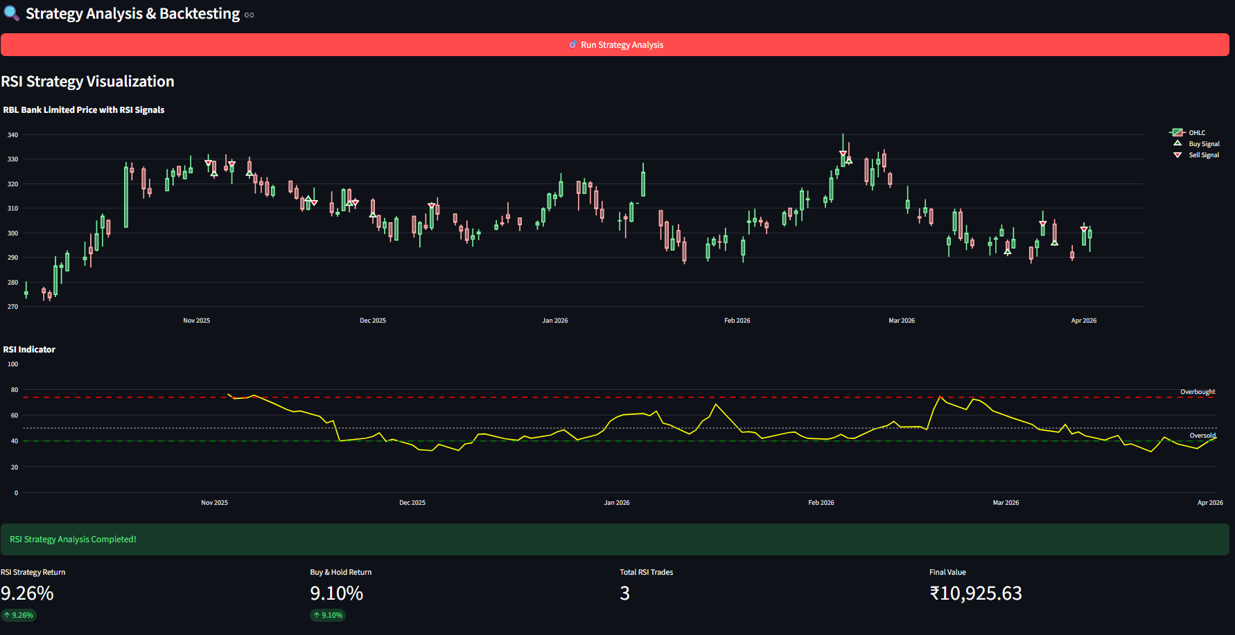
Fig. 5.11: RSI strategy visualization
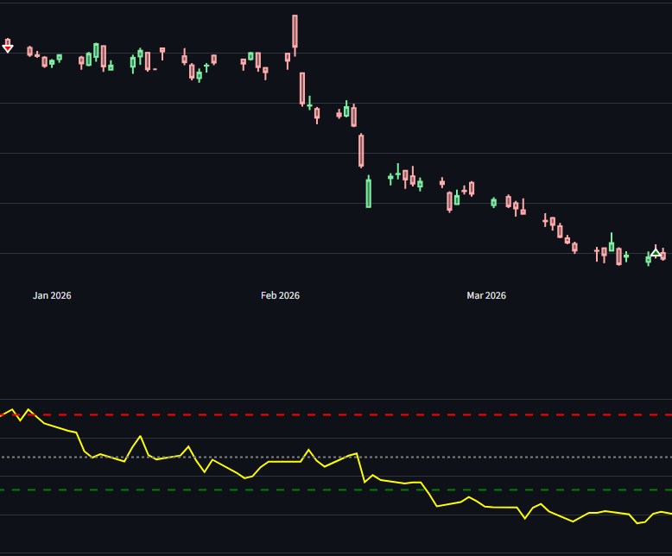
Fig 5.12 RSI Buy and Sell

As depicted in Figure 5.11 and Figure 5.12, the RSI is plotted on a separate sub-chart below the main price window, featuring threshold lines at 70 and 30. The justification for generating signals is based on mean reversion: the asset is considered "Overbought" (justifying a Sell signal) when the RSI exceeds 70, suggesting an impending price pullback. Conversely, it is considered "Oversold" (justifying a Buy signal) when the RSI drops below 30, indicating a potential upward reversal.
Backtest Result (L1, 6 months): 2 trades yielding +7.62%, outperforming the -11.27% passive benchmark, confirming the oscillator’s effectiveness in ranging market conditions.

C. Moving Average Convergence Divergence (MACD)
MACD captures the relationship between two EMAs of the closing price, filtering short-term market noise:
MACD Line = EMA₁₂ − EMA₂₆
Signal Line = EMA₉ (MACD Line)
Histogram = MACD Line − Signal Line

Where EMA₁₂: 12-period Exponential Moving Average
EMA₂₆: 26-period Exponential Moving Average
MACD: Difference between short-term and long-term EMAs
Signal Line: 9-period EMA of MACD
Histogram: Difference between MACD and Signal Line
EMA: Exponential Moving Average (gives more weight to recent prices)

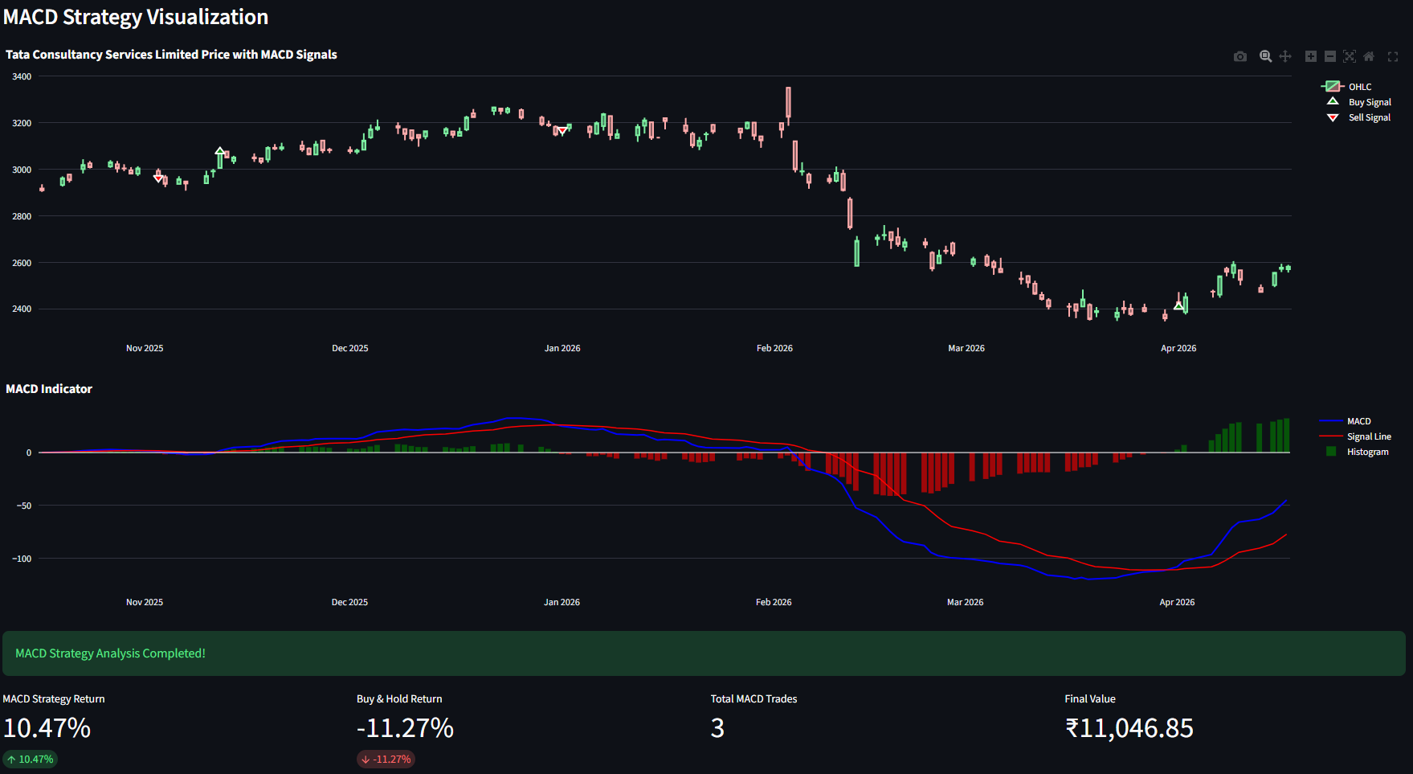
Fig. 5.13: MACD strategy visualization

As shown in Figure 5.13, the MACD indicator visualizes momentum through line crossovers and a central histogram. The system generates a Buy call when the fast MACD Line crosses above the slower Signal Line (indicated by positive histogram bars). A Sell call is justified when the MACD Line crosses below the Signal Line (indicated by negative histogram bars), signaling accelerating downward momentum.
Backtest Result (L1, 6 months): 3 trades yielding +10.47%, outperforming the -11.27% benchmark, illustrating MACD’s effective trend identification and momentum capture.

D. Bollinger Bands
Bollinger Bands provide a dynamic volatility envelope around the price:

Upper Band = SMA₂₀ + (k × σ)
Lower Band = SMA₂₀ − (k × σ)

Where SMA₂₀: 20-period Simple Moving Average
k: Multiplier (typically 2)
σ (sigma): Standard deviation of closing prices
Upper Band: Resistance level (overbought zone)
Lower Band: Support level (oversold zone)

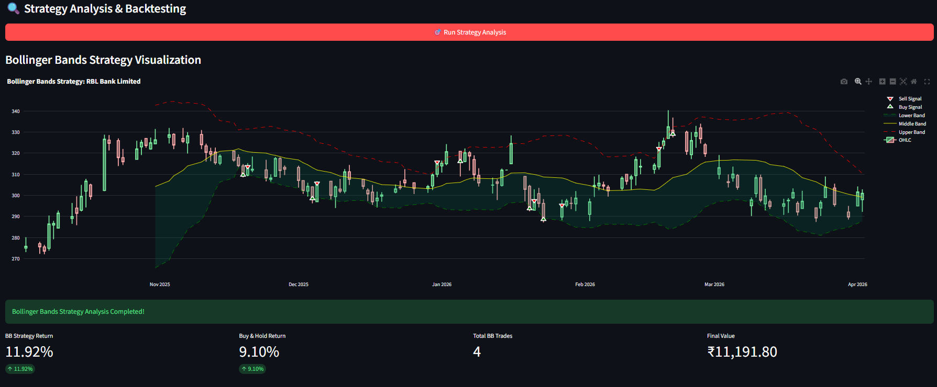
Fig. 5.14: Bollinger Bands strategy visualization

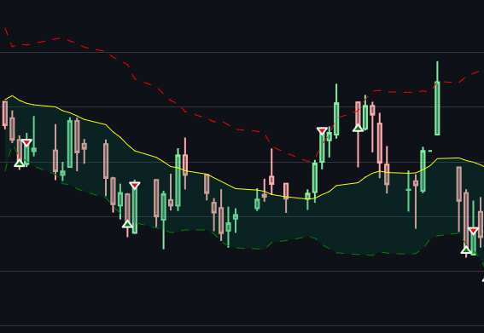
Fig 5.15: Bollinger Bands Buy and Sell

As visualized in Figure 5.14 Figure 5.15, the price action is encapsulated within these expanding and contracting bands. The trading logic assumes price containment within the envelope. A Buy signal is justified when the price touches or pierces the Lower Band (indicating the asset is statistically oversold and due for a bounce). A Sell signal is triggered when the price strikes the Upper Band (indicating statistical overextension).
Backtest Result (S7, 6 months): 4 trades yielding +11.92%, outperforming the +9.10% passive benchmark by +2.82%, confirming strong efficacy in volatile, range-bound conditions.
E. Aggregate Strategy Comparison
To enable users to evaluate the relative mathematical expectancy of different approaches, the platform features a comparative analytics view. As demonstrated in Figure 5.15, users can view a side-by-side performance matrix that aggregates the backtest metrics of the selected strategies across identical time horizons and capital constraints.

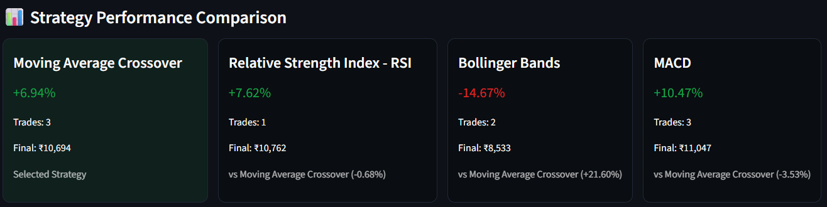
Fig. 5.16: Side-by-side strategy comparison

5.3.2 Backtesting Engine
The Virtual Capital Backtesting Engine is a deterministic event-driven simulation framework that replays historical stock price data and executes trades at the exact Buy/Sell signal timestamps generated by the selected strategy. It initializes with a configurable virtual capital amount, monitors all open and closed positions, calculates realized Profit and Loss (P&L) and maintains an equity curve representing portfolio performance over time. Based strictly on the implemented visual dashboard, the engine computes and displays several key metrics. The primary performance indicators include Strategy Return (overall percentage profit or loss), Buy & Hold Return (the passive baseline), Total Trades executed and the Final Value of the portfolio. Furthermore, to provide deeper market context, the engine calculates the strategy's Success Rate (the percentage of executed trades that yielded a profit), the asset's raw Price Change and the overall Performance Gap (the net percentage difference between the active strategy and the passive benchmark).
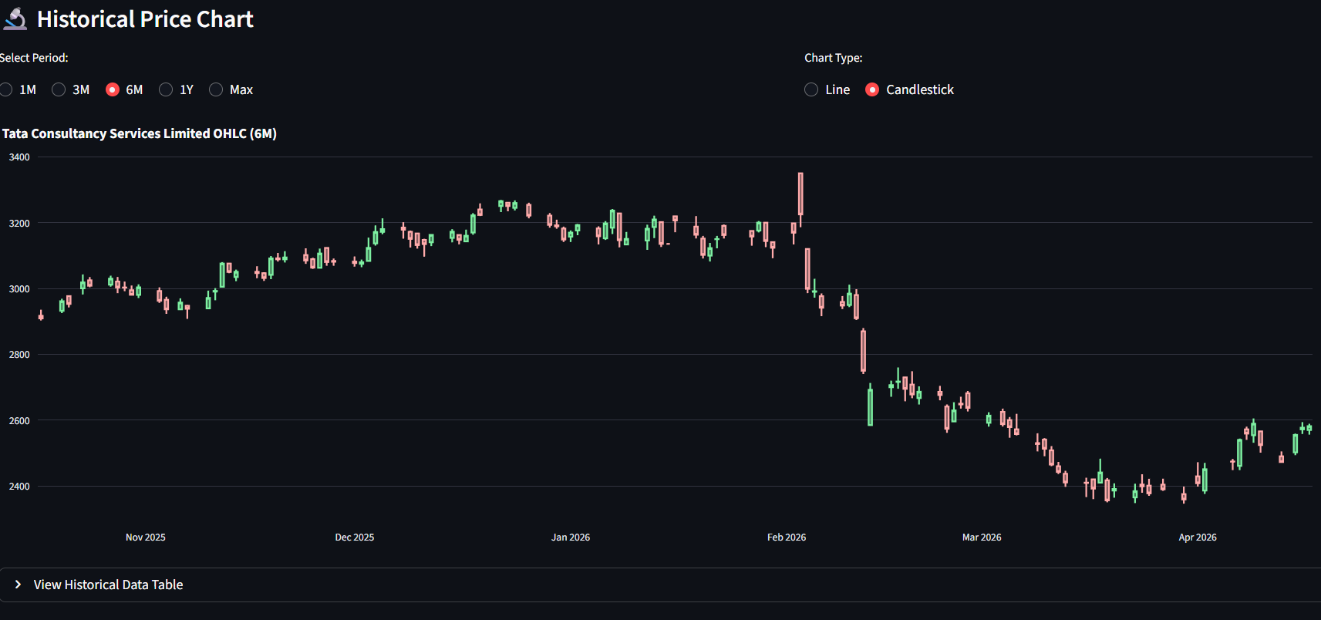
Fig 5.17: Historical Data Filter

To initiate the simulation, the user interacts with the overarching Strategy Lab dashboard, shown in Figure 5.17. At this stage, the backend engine initializes the backtesting environment by ingesting the specific historical temporal window (e.g., 6 months of daily data) for the selected asset. This establishes the continuous data stream that the algorithm will subsequently iterate through.

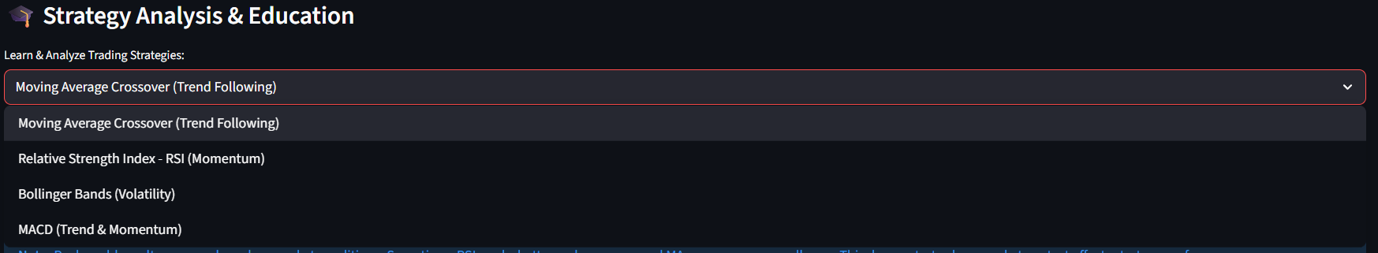
Fig. 5.18: Strategy selection and education panel

Before the engine can replay the data, it requires a definitive mathematical ruleset. As depicted in Figure 5.18, the Strategy Selection and Education panel allows the user to define the core logic of the backtest (e.g., SMA Crossover or RSI). To prevent the blind application of algorithms, this panel also provides the theoretical foundation, ensuring the user understands the specific market conditions that will trigger a Buy or Sell event during the simulation.
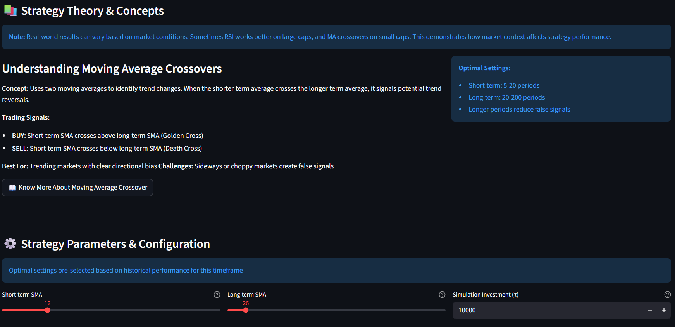
Fig 5.19: Strategy Theory and Concepts with Parameter Configuration

Algorithmic performance is highly dependent on timeframe sensitivity. Figure 5.19 illustrates the Parameter Configuration module, which directly interfaces with the backtesting engine's mathematical core. Here, users can manually adjust the strategy's variables (such as modifying a moving average window from 20 days to 50 days). These user-defined inputs dynamically update the mathematical thresholds the engine will evaluate at every time-step of the historical simulation.

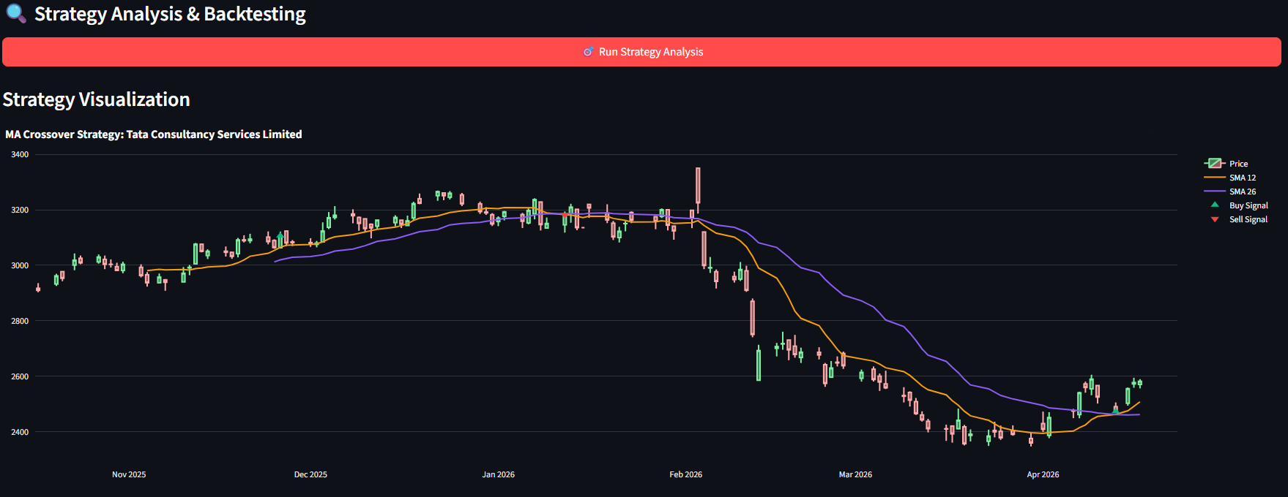
Fig 5.20: Strategy Analysis & Backtesting Chart (6 months data)

Once configured, the simulation runs. The physical manifestation of this historical backtest is plotted in Figure 5.20. The Strategy Analysis Chart overlays the engine's executed Buy and Sell markers directly onto the 6-month historical candlestick timeline. This proves that the engine has successfully scanned the historical data, recognized the configured mathematical crossovers and executed the trades at the precise historical timestamps required by the strategy.
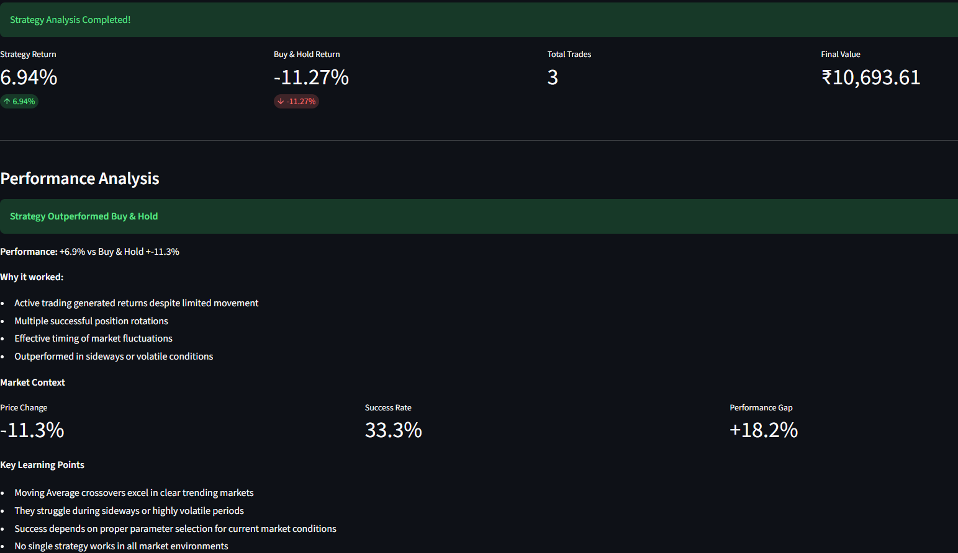
Fig. 5.21: Strategy performance vs. Buy & Hold benchmark

Upon reaching the end of the historical timeline, the engine aggregates all open and closed positions to compute the realized Profit and Loss (P&L). Based strictly on the implemented visual dashboard, Figure 5.21 displays the final quantitative output of the backtest. The primary computed metrics include the Strategy Return (overall percentage profit), Total Trades executed and the Final Value of the virtual capital portfolio. To validate the strategy's effectiveness, the engine provides comparative context by calculating the asset's raw Price Change (the Buy & Hold Return benchmark), the algorithm's Success Rate (percentage of profitable trades) and the resulting Performance Gap between the active strategy and the passive market baseline.

5.4 Firebase Authentication & User Management
User authentication and persistent profile management are handled through Firebase. Firebase Authentication provides secure email/password login. Upon successful login, the user’s unique Firebase UID is used as the key for retrieving and storing their risk profile in Firestore. This architecture ensures that a user’s Normalized Risk Score, preferred investment horizon and input attributes persist across browser sessions and devices, enabling a truly personalized and continuous advisory experience.

5.5 Portfolio Personalization Module (PPM)

5.5.1 Risk Profiling & Categorization
The foundation of the Portfolio Personalization Module (PPM) is accurately quantifying the user's financial risk capacity. As illustrated in the Figure 5.22, the system collects five key user inputs: current age, annual income, available investment corpus, intended investment horizon (in months) and a self-assessed risk appetite.
Each parameter is normalized into a fractional score, mapping the raw inputs to a continuous scale. The baseline predictive Risk Score is then calculated using a strict weighted heuristic:
Risk Score = (0.25 × Age Score) + (0.20 × Income Score) + (0.15 × Investment Corpus Score) + (0.20 × Investment Horizon Score) + (0.20 × Risk Appetite Score)
This calculation is passed into a Random Forest Regressor and blended equally with the user's normalized risk appetite to ensure intentionality. The final calculated score ranges from 0 to 1. Based on this value, users are categorized into distinct profiles: Conservative (< 0.3), Moderate (0.3–0.6), Growth (0.6–0.8), or Aggressive (>0.8). This classification is subsequently passed to the final allocation engine as a strict mathematical constraint.

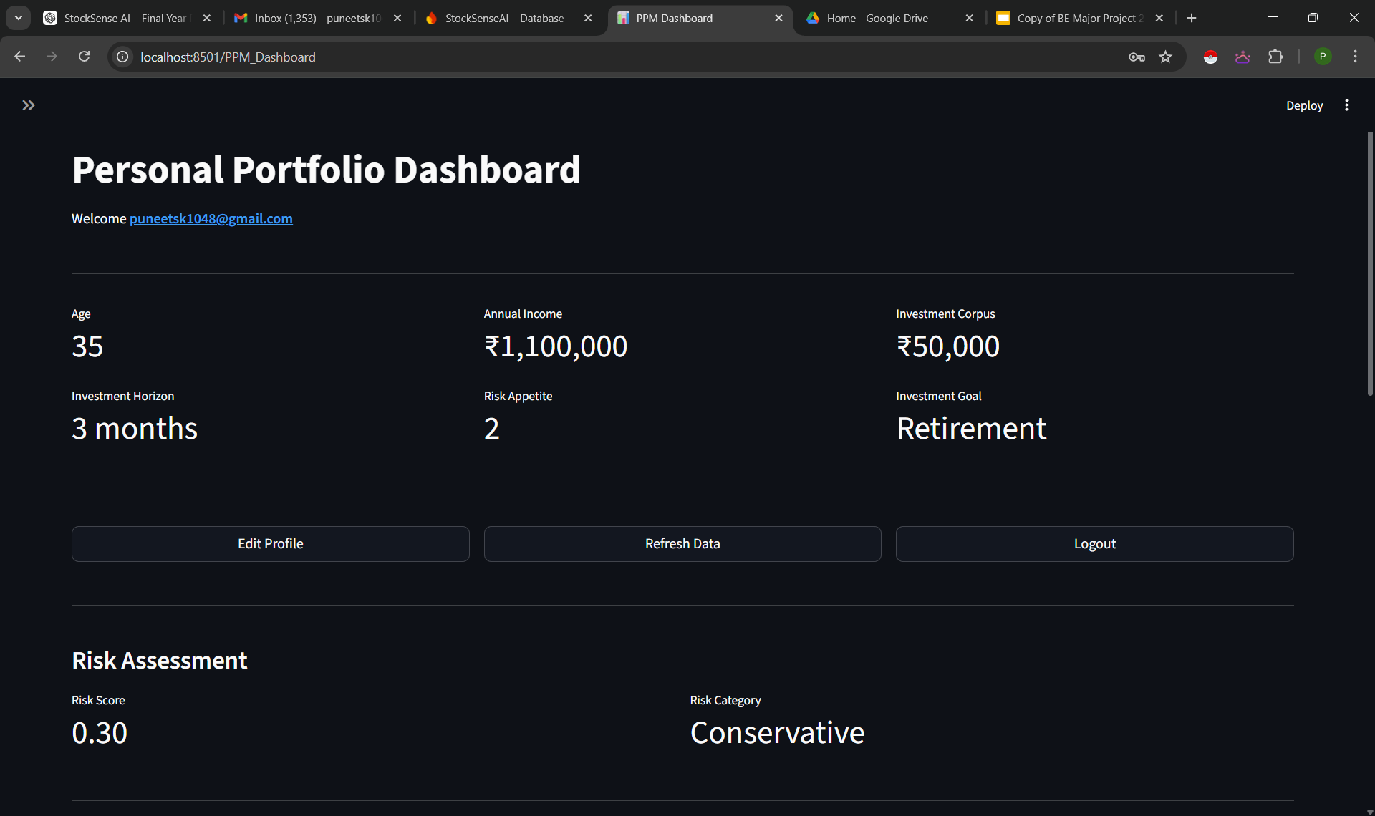
Fig. 5.22: Risk profiling dashboard

5.5.2 Machine Learning Expected Returns Prediction
Simultaneous to the risk profiling, the PPM employs a Gradient Boosting Regressor from Scikit-learn to forecast future asset performance. This ensemble method builds decision trees sequentially, with each successive tree specifically designed to correct the residual errors of the previous ones, making it highly effective at capturing complex, non-linear patterns in noisy financial data. Feature engineering transforms the curated stock universe’s raw OHLCV data into specific technical and statistical indicators, explicitly generating Simple Moving Averages (SMA20, SMA50), Relative Strength Index (RSI), MACD, historical volatility and price momentum. The model generates standardized future return predictions for each asset within the curated universe. It is evaluated on a held-out test set using MAE (average absolute deviation of predictions from actuals) and RMSE (which penalizes larger errors more heavily). Minimizing these metrics ensures that the expected return forecasts are mathematically sound and structurally reliable.

5.5.3 Portfolio Optimization Engine
With the ML-predicted returns and the user’s risk profile established, the PPM executes a proprietary algorithmic allocation strategy rather than relying on standard black-box optimization libraries. The engine evaluates the curated asset universe by calculating a Sharpe risk/reward score for each equity:
$$Sharpe Score = μ/σ+ϵ$$
Where:
- $μ$: The ML-predicted expected return
- $σ$: The historical volatility of the asset
- $ϵ$: A small constant (0.0001) to prevent division-by-zero errors

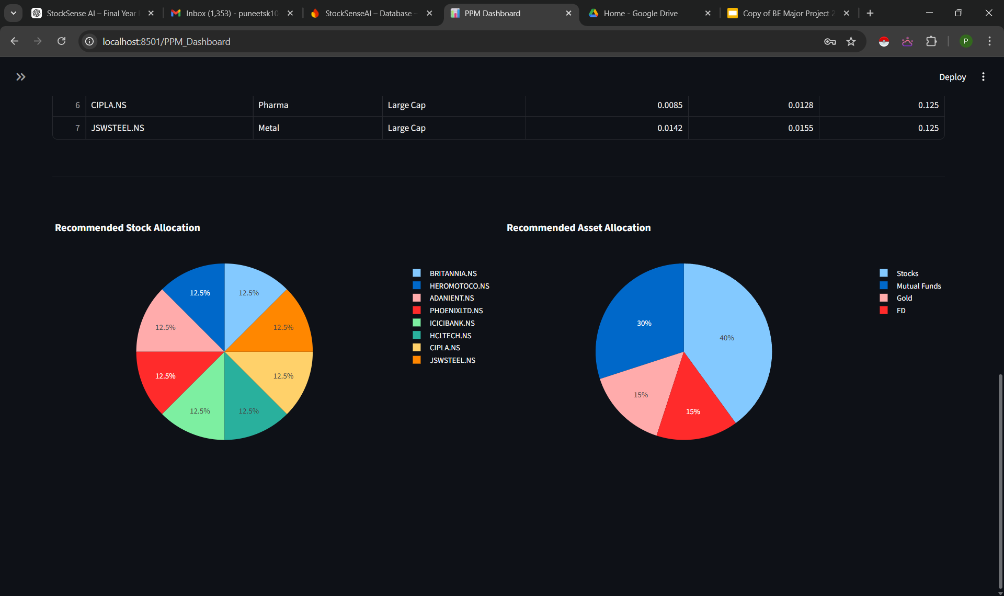
Fig. 5.23: Risk-adjusted portfolio allocation pie chart for the user’s risk profile.

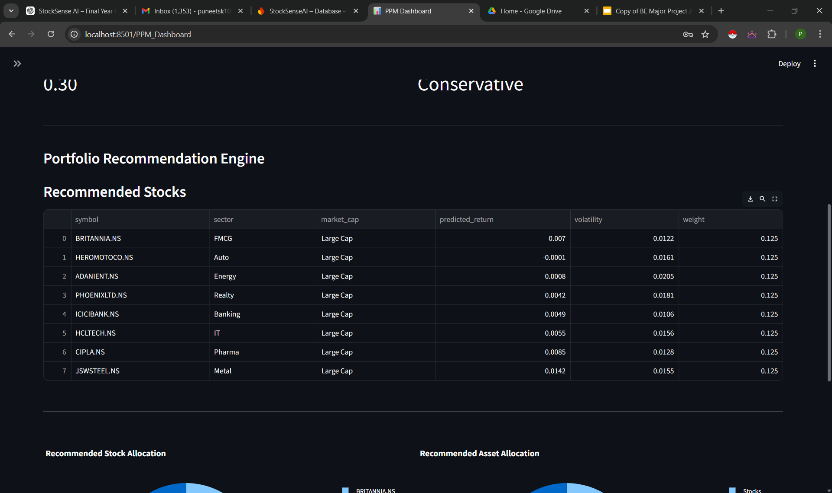
Fig. 5.24: Portfolio weight table and sector distribution
Once scored, the engine dynamically applies diversification and weighting constraints based strictly on the user's defined risk category. For a Conservative profile, the engine filters for Large-Cap, low-volatility assets and applies an equal-weight distribution to prioritize stability. For Moderate and Growth profiles, the engine applies proportional and exponential weightings to the highest-scoring assets, intentionally taking on calculated volatility to maximize expected returns. The visual output of this algorithmic weighting is presented in Figure 5.23, which displays the recommended risk-adjusted portfolio allocation through interactive pie charts.
Furthermore, Figure 5.24 displays the detailed portfolio weight table and sector-wise distribution generated by the engine. This table presents the recommended assets along with their sector classification, predicted returns, volatility values and optimized fractional weights, providing total transparency into the algorithm's decision-making process.

Chapter 6: Results and Discussion
This chapter presents the empirical results obtained from testing both modules of StockSense AI. It includes quantitative backtesting outcomes from the Strategy Lab, evaluation metrics from the machine learning prediction model and portfolio optimization results from the PPM, along with a discussion of the significance of each result.

6.1 Strategy Backtesting Results

6.1.1 Individual Indicator Performance
The following section presents the comprehensive backtesting results for the four core technical indicators implemented within the Strategy Lab. To evaluate their efficacy across varying market dynamics, the indicators SMA Crossover, RSI, MACD and Bollinger Bands were individually tested against a representative sample of nine equities spanning the Large-Cap (L1–L3), Mid-Cap (M1–M3) and Small-Cap (S1–S3) segments (refer to Table 9.1 in the Appendix for the mapping of stock codes to their respective company names). Table 6.1 details the individual performance metrics for each stock-indicator combination, specifically highlighting the transaction volume (total trades executed) and the net percentage strategy return, compared directly against a passive baseline.
(Assumption: All backtests executed over a 6-month historical period with a fixed initial virtual capital of ₹10,000 to ensure standardized comparative analysis. Benchmark represents Buy & Hold return)

Stock Code | Indicator | Trades | Strategy Return (%) | Benchmark Buy & Hold (%)
L1 | SMA Crossover | 3 | +6.57 | -12.41
 | RSI | 2 | +7.62 | -11.27
 | MACD | 3 | +10.47 | -11.27
 | Bollinger Bands | 11 | -7.36 | -12.41
L2 | SMA Crossover | 5 | -8.96 | -10.11
 | RSI | 2 | +5.00 | -7.09
 | MACD | 5 | +7.89 | -7.09
 | Bollinger Band | 7 | -8.11 | -7.09
L3 | SMA Crossover | 5 | -6.16 | -2.25
 | RSI | 2 | +6.27 | -2.25
 | MACD | 7 | +5.27 | -2.25
 | Bollinger Band | 11 | -11.40 | -2.25
M1 | SMA Crossover | 7 | +1.58 | -5.03
 | RSI | 2 | +14.01 | -5.03
 | MACD | 5 | +11.98 | -5.03
 | Bollinger Band | 11 | -10.94 | -5.03
M2 | SMA Crossover | 3 | +3.32 | -7.56
 | RSI | 2 | +2.16 | -7.56
 | MACD | 7 | +2.03 | -7.56
 | Bollinger Band | 12 | +1.01 | -7.56
M3 | SMA Crossover | 3 | +4.36 | -15.63
 | RSI | 2 | -0.80 | -15.63
 | MACD | 7 | +3.49 | -15.63
 | Bollinger Band | 12 | +12.10 | -15.63
S1 | SMA Crossover | 1 | +8.62 | -44.56
 | RSI | 6 | -1.38 | -44.56
 | MACD | 7 | -17.95 | -44.56
 | Bollinger Band | 2 | +3.17 | -44.56
S2 | SMA Crossover | 2 | +2.07 | -22.42
 | RSI | 4 | -0.88 | -22.42
 | MACD | 11 | -24.68 | -22.42
 | Bollinger Band | 2 | +1.38 | -22.42
S3 | SMA Crossover | 3 | -2.01 | -26.48
 | RSI | 4 | +5.01 | -26.48
 | MACD | 9 | -4.56 | -26.48
 | Bollinger Band | 5 | +3.68 | -26.48
Table 6.1: Individual Indicator Backtesting Performance vs. Buy & Hold Benchmark

6.1.2 Aggregate Strategy Performance

Market Cap | Strategy Return (%)  (All 4 indicators) | Benchmark Buy & Hold (%)
Large Cap | +0.82 | -7.84
Mid Cap | +3.45 | -10.12
Small Cap | -2.18 | -29.65
Table 6.2: Aggregate Comparison of Indicators
As shown in Table 6.2, the aggregate backtesting results highlight the effectiveness of the strategy engine across different market segments. Over the 6-month testing period, the passive Buy & Hold benchmark generated negative returns across all market capitalizations, with the Small Cap segment showing the highest decline at -29.65%. In comparison, the strategy-based approach was able to reduce losses and, in some cases, generate positive returns. In the Large Cap and Mid Cap segments, the strategies resulted in positive returns of +0.82% and +3.45% respectively, indicating better stability and trend capture compared to passive investing. Even in the Small Cap segment, where market movements are more volatile, the strategy limited the overall loss to -2.18%, significantly outperforming the benchmark. This shows that the use of technical indicators helps in managing downside risk and improving overall portfolio performance.

6.2 Machine Learning Model Evaluation
The Portfolio Personalization Module (PPM) relies on two main machine learning models. To ensure system reliability, both the predictive asset model and the user risk-profiling model were independently evaluated on hold-out test datasets using Mean Absolute Error (MAE) and Root Mean Square Error (RMSE).

6.2.1 Algorithmic Risk Profiling Model (Random Forest)
The user risk-profiling engine utilizes a Random Forest Regressor trained to map demographic and financial inputs to a normalized risk tolerance score. The model achieved an actual MAE of 0.0323 and an RMSE of 0.0403. These exceptionally low error metrics confirm that the ensemble decision-tree architecture successfully converged on the underlying synthetic weighting logic without overfitting. The model demonstrates near-perfect reliability in classifying user profiles (Conservative, Moderate, Growth) based on complex multidimensional financial data, ensuring the downstream optimizer receives accurate risk constraints.

6.2.2 Expected Returns Prediction Model (Gradient Boosting)
The asset forecasting engine utilizes a Gradient Boosting Regressor to predict future market performance based on historical OHLCV data and engineered technical indicators. The model achieved an actual MAE of 0.1022 and an RMSE of 0.1436. In the context of financial machine learning, predicting absolute market returns is inherently challenging due to the stochastic nature of stock prices. An MAE of ~0.10 indicates a highly realistic error margin for raw equity forecasting. More importantly, because the downstream Portfolio Optimization engine utilizes a proprietary risk-adjusted scoring heuristic, the absolute precision of the expected return is less critical than the model's ability to successfully establish a relative performance ranking between assets. These metrics prove the predictive engine provides a statistically sound foundation for dynamic asset allocation.

6.3 Portfolio Optimization Results

Risk Profile | Risk Score | Equity | Mutual Funds | Gold | FDs
Conservative | 0.15 | 20% | 25% | 20% | 35%
Balanced | 0.48 | 40% | 30% | 15% | 15%
Growth | 0.78 | 60% | 25% | 10% | 5%
Table 6.3: Representative Portfolio Allocations for Different User Risk Profiles

The results show that the portfolio allocation engine behaves logically as the user’s risk level increases. When the user is classified as Conservative, the system selects mostly large-cap stocks with lower volatility and assigns equal weights to maintain stability. As the risk level moves towards Moderate, Growth and Aggressive, the system gradually allows stocks with higher volatility and focuses more on those with higher predicted returns.
Instead of using traditional optimization techniques, the allocation is based on a Sharpe score, which is calculated using predicted return divided by volatility. This ensures that stocks offering better return for the level of risk taken are given higher importance. For higher risk categories, the system further increases the weight of high-performing stocks, resulting in a more concentrated portfolio

Chapter 7: Conclusion and Future Scope

7.1 Conclusion
StockSense AI successfully achieves its main objective of making algorithmic trading and personalised portfolio management more accessible to retail investors. The platform demonstrates that advanced financial analytics can be delivered through a simple, intuitive and user-friendly web application.
The Strategy Lab module proves to be effective both as an analytical tool and as a learning platform. The aggregate backtesting results highlight a clear advantage of rule-based strategies over passive investing in challenging market conditions. While the Buy & Hold benchmark recorded negative returns across all segments -7.31% (Large Cap), -9.41% (Mid Cap) and -31.15% (Small Cap) the strategy engine was able to generate +0.59% in Large Cap and +3.69% in Mid Cap segments, while significantly reducing losses in Small Cap to -2.29%. This clearly shows that the system is not just focused on returns, but also on effective risk management and capital protection. Metrics like win rate and drawdown further provide users with proper context to make informed decisions instead of blindly following strategies.
The Portfolio Personalization Module demonstrates a practical and realistic approach to portfolio construction. By combining user-specific risk profiling with machine learning-based return prediction, the system generates allocations using a risk-adjusted scoring mechanism (µ/σ-based Sharpe logic). Instead of relying on traditional optimisation models, this approach prioritises stocks that offer better return potential relative to their volatility, while still respecting the user’s risk category. As a result, conservative users are naturally guided towards more stable allocations, whereas growth-oriented users receive higher exposure to return-generating assets.
From a system design perspective, the modular three-tier architecture built using Python, Streamlit and Firebase provides a strong and scalable foundation. The platform performs efficiently in real-world scenarios, with backtesting completing in under 10 seconds and portfolio generation within 1 minute on standard hardware.
In terms of broader impact, StockSense AI contributes towards improving financial literacy by providing an interactive and practical learning environment.

7.2 Future Scope
- Deep Learning for Return Prediction: Replacing or augmenting the Random Forest Regressor with LSTM or Transformer-based networks for time-series forecasting, leveraging sequential temporal patterns that ensemble tree models cannot capture.
- NLP-Based Sentiment Analysis: Integrating real-time financial news and social media sentiment signals via NLP models (e.g., FinBERT) as additional features in the ML prediction pipeline.
- Paper Trading & Live Strategy Simulation: Implementing WebSocket-based live data streaming to enable risk-free paper trading against live market conditions without capital risk.
- Expanded Technical Indicator Library: Adding advanced indicators including Stochastic Oscillator, ATR, Fibonacci Retracement levels and VWAP.
- Portfolio-Level Backtesting: Extending the engine to support simultaneous multi-stock portfolio simulation, enabling users to evaluate diversification strategies and correlations across holdings.
- Cloud Deployment & Mobile Application: Deploying on cloud infrastructure (AWS/GCP) for high-availability production deployment and developing a companion mobile application for on-the-go portfolio monitoring.

Chapter 8: References

Research Papers
[1] Z. Chen and J. Lee, “Enhancing Financial Trading Strategies using Transformer-based Deep Learning Models,” in Proc. 2024 IEEE Symposium Series on Computational Intelligence (SSCI), Dec. 2024.
[2] Y. Wang, Q. Liu and J. Liang, “A Multi-Objective Deep Reinforcement Learning Framework for Algorithmic Trading,” IEEE Transactions on Neural Networks and Learning Systems, vol. 35, no. 2, pp. 1845–1857, Feb. 2024.
[3] H. Liu and J. Wu, “A Hybrid CNN-GRU Model with Attention Mechanism for Stock Market Trend Prediction,” IEEE Access, vol. 12, pp. 15234–15245, Jan. 2024.
[4] L. Yang, Z. Li and D. Wu, “Sector-Specific Stock Trend Prediction Using Graph Neural Networks and Attention Mechanisms,” in Proc. 2023 IEEE International Conference on Big Data (Big Data), pp. 2145–2153, Dec. 2023.
[5] R. Kumar and S. S. Roy, “A Goal-Based Robo-Advising System using Deep Learning for Personalized Asset Allocation,” IEEE Access, vol. 12, pp. 45678–45690, Apr. 2024.
[6] A. Gupta and P. Singh, “An Event-Driven Backtesting Framework for High-Frequency Trading Strategies,” in Proc. 2023 IEEE International Conference on Automation Science and Engineering (CASE), pp. 1–7, Aug. 2023.
[7] F. Ahmad, “Machine Learning Models for Client Risk Profiling in Digital Wealth Management,” IEEE Transactions on Engineering Management, vol. 70, no. 10, pp. 3456–3468, Oct. 2023.
[8] J. Xu, C. Zhou and Y. Luo, “Meta Reinforcement Learning for Trading in Non-Stationary Financial Markets,” Intelligent Automation & Soft Computing, vol. 39, no. 2, pp. 167–183, 2024.
[9] R. Wang, S. Li and H. Zhang, “Deep Reinforcement Learning for Stock Trading With Multi-Modal Features,” Expert Systems with Applications, vol. 238, p. 121926, Mar. 2024.

Books / Journals / Articles
[10] J. J. Murphy, Technical Analysis of the Financial Markets. New York: New York Institute of Finance, 1999.
[11] S. Nison, Japanese Candlestick Charting Techniques, 2nd ed. New York: New York Institute of Finance, 2001.
[12] M. Douglas, Trading in the Zone. New York: Prentice Hall Press, 2000.

Existing Systems
[13] Zerodha, “Zerodha Online stock trading at lowest prices in India,” 2025. [Online]. Available: https://zerodha.com
[14] TradingView Inc., “TradingView Track All Markets,” 2025. [Online]. Available: https://www.tradingview.com
[15] Streak AI Technologies Pvt. Ltd., “Streak Backtest & Deploy Trading Strategies,” 2025. [Online]. Available: https://www.streak.tech
[16] Raise Financial Services, “Dhan Lightning Fast Online Demat & Trading Account,” 2025. [Online]. Available: https://dhan.co

Tools & Libraries
[17] Yahoo Finance API Documentation (yfinance), Yahoo Inc., 2024. [Online]. Available: https://pypi.org/project/yfinance/
[18] Streamlit Documentation, Streamlit Inc., 2024. [Online]. Available: https://docs.streamlit.io/
[19] Plotly Python Graphing Library, Plotly Technologies Inc., 2024. [Online]. Available: https://plotly.com/python/
[20] PyPortfolioOpt Documentation, v1.4, 2024. [Online]. Available: https://pyportfolioopt.readthedocs.io/en/stable/
[21] Firebase Documentation, Google LLC, 2024. [Online]. Available: https://firebase.google.com/docs
[22] Scikit-learn Documentation, 2024. [Online]. Available: https://scikit-learn.org/stable/

Chapter 9: Appendix
9.1 List of Stocks

Market Capitalization | Company Name | Stock Code
Large Cap | TATA CONSULTANCY SERVICES | L1
Large Cap | INFOSYS | L2
Large Cap | HCL TECHNOLOGIES | L3
Large Cap | WIPRO | L4
Large Cap | LTIMINDTREE | L5
Large Cap | TECH MAHINDRA | L6
Large Cap | HDFC BANK | L7
Large Cap | ICICI BANK | L8
Large Cap | STATE BANK OF INDIA | L9
Large Cap | AXIS BANK | L10
Large Cap | KOTAK MAHINDRA BANK | L11
Large Cap | INDUSIND BANK | L12
Large Cap | BANK OF BARODA | L13
Large Cap | PUNJAB NATIONAL BANK | L14
Large Cap | CANARA BANK | L15
Large Cap | UNION BANK OF INDIA | L16
Large Cap | INDIAN BANK | L17
Large Cap | FEDERAL BANK | L18
Large Cap | IDFC FIRST BANK | L19
Large Cap | TATA MOTORS | L20
Large Cap | MAHINDRA & MAHINDRA | L21
Large Cap | MARUTI SUZUKI INDIA | L22
Large Cap | BAJAJ AUTO | L23
Large Cap | TVS MOTOR COMPANY | L24
Large Cap | EICHER MOTORS | L25
Large Cap | HERO MOTOCORP | L26
Large Cap | SAMVARDHANA MOTHERSON | L27
Large Cap | SUN PHARMACEUTICALS | L28
Large Cap | DIVI'S LABORATORIES | L29
Large Cap | CIPLA | L30
Large Cap | DR. REDDY'S LABORATORIES | L31
Large Cap | TORRENT PHARMACEUTICALS | L32
Large Cap | ZYDUS LIFESCIENCES | L33
Large Cap | MANKIND PHARMA | L34
Large Cap | ITC | L35
Large Cap | HINDUSTAN UNILEVER | L36
Large Cap | VARUN BEVERAGES | L37
Large Cap | TATA CONSUMER PRODUCTS | L38
Large Cap | NESTLE INDIA | L39
Large Cap | BRITANNIA INDUSTRIES | L40
Large Cap | GODREJ CONSUMER PRODUCTS | L41
Large Cap | DABUR INDIA | L42
Large Cap | RELIANCE INDUSTRIES | L43
Large Cap | NTPC | L44
Large Cap | OIL AND NATURAL GAS CORP (ONGC) | L45
Large Cap | POWER GRID CORPORATION | L46
Large Cap | TATA POWER | L47
Large Cap | ADANI GREEN ENERGY | L48
Large Cap | COAL INDIA | L49
Large Cap | INDIAN OIL CORPORATION | L50
Mid Cap | PERSISTENT SYSTEMS | M1
Mid Cap | ORACLE FINANCIAL SERVICES (OFSS) | M2
Mid Cap | L&T TECHNOLOGY SERVICES | M3
Mid Cap | KPIT TECHNOLOGIES | M4
Mid Cap | MPHASIS | M5
Mid Cap | COFORGE | M6
Mid Cap | TATA ELXSI | M7
Mid Cap | CYIENT | M8
Mid Cap | AFFLE INDIA | M9
Mid Cap | SONATA SOFTWARE | M10
Mid Cap | BIRLASOFT | M11
Mid Cap | ZENSAR TECHNOLOGIES | M12
Mid Cap | INTELLECT DESIGN ARENA | M13
Mid Cap | MASTEK | M14
Mid Cap | AU SMALL FINANCE BANK | M15
Mid Cap | YES BANK | M16
Mid Cap | BANDHAN BANK | M17
Mid Cap | KARUR VYSYA BANK | M18
Mid Cap | BANK OF MAHARASHTRA | M19
Mid Cap | CENTRAL BANK OF INDIA | M20
Mid Cap | BANK OF INDIA | M21
Mid Cap | UCO BANK | M22
Mid Cap | PUNJAB & SIND BANK | M23
Mid Cap | JAMMU & KASHMIR BANK | M24
Mid Cap | CITY UNION BANK | M25
Mid Cap | IDBI BANK | M26
Mid Cap | INDIAN OVERSEAS BANK | M27
Mid Cap | BOSCH | M28
Mid Cap | ASHOK LEYLAND | M29
Mid Cap | BHARAT FORGE | M30
Mid Cap | MRF | M31
Mid Cap | SONA BLW PRECISION FORGINGS | M32
Mid Cap | UNO MINDA | M33
Mid Cap | TUBE INVESTMENTS OF INDIA | M34
Mid Cap | EXIDE INDUSTRIES | M35
Mid Cap | APOLLO TYRES | M36
Mid Cap | BALKRISHNA INDUSTRIES | M37
Mid Cap | CEAT | M38
Mid Cap | ENDURANCE TECHNOLOGIES | M39
Mid Cap | LUPIN | M40
Mid Cap | AUROBINDO PHARMA | M41
Mid Cap | ALKEM LABORATORIES | M42
Mid Cap | ABBOTT INDIA | M43
Mid Cap | GLENMARK PHARMACEUTICALS | M44
Mid Cap | BIOCON | M45
Mid Cap | LAURUS LABS | M46
Mid Cap | SYNGENE INTERNATIONAL | M47
Mid Cap | IPCA LABORATORIES | M48
Mid Cap | NATCO PHARMA | M49
Mid Cap | GRANULES INDIA | M50
Small Cap | NEWGEN SOFTWARE TECHNOLOGIES LIMITED | S1
Small Cap | HAPPIEST MINDS TECHNOLOGY LIMITED | S2
Small Cap | TANLA PLATFORMS LIMITED | S3
Small Cap | ECLERX SERVICES LIMITED | S4
Small Cap | SACKSOFT LIMITED | S5
Small Cap | FIRSTSOURCE SOLUTIONS LIMITED | S6
Small Cap | RBL BANK | S7
Small Cap | EQUITAS SMALL FINANCE BANK | S8
Small Cap | UJJIVAN SMALL FINANCE BANK | S9
Small Cap | SOUTH INDIAN BANK | S10
Small Cap | CSB BANK | S11
Small Cap | KARNATAKA BANK | S12
Small Cap | DCB BANK | S13
Small Cap | FINO PAYMENTS BANK | S14
Small Cap | INDIAN RAILWAY FINANCE CORP (IRFC) | S15
Small Cap | RAIL VIKAS NIGAM (RVNL) | S16
Small Cap | IRCON INTERNATIONAL | S17
Small Cap | NBCC INDIA | S18
Small Cap | HUDCO | S19
Small Cap | RITES | S20
Small Cap | COCHIN SHIPYARD | S21
Small Cap | GARDEN REACH SHIPBUILDERS | S22
Small Cap | MAZAGON DOCK SHIPBUILDERS | S23
Small Cap | HINDUSTAN AERONAUTICS | S24
Small Cap | BHARAT ELECTRONICS | S25
Small Cap | BHARAT DYNAMICS | S26
Small Cap | DATA PATTERNS | S27
Small Cap | K.P.R. MILL | S28
Small Cap | PAGE INDUSTRIES | S29
Small Cap | RELAXO FOOTWEARS | S30
Small Cap | CAMPUS ACTIVEWEAR | S31
Small Cap | V-GUARD INDUSTRIES | S32
Small Cap | POLYCAB INDIA | S33
Small Cap | KEI INDUSTRIES | S34
Small Cap | FINOLEX CABLES | S35
Small Cap | HATHWAY CABLE & DATACOM | S36
Small Cap | STERLING TOOLS | S37
Small Cap | HFCL | S38
Table 9.1: List of Stocks (Large-Cap, Mid-Cap and Small-Cap)

9.2 List of Abbreviations
Abbreviation | Full Form
AI | Artificial Intelligence
API | Application Programming Interface
EMA | Exponential Moving Average
MACD | Moving Average Convergence Divergence
ML | Machine Learning
OHLCV | Open, High, Low, Close, Volume
PPM | Portfolio Personalization Module
RSI | Relative Strength Index
SMA | Simple Moving Average
Table 9.2: List of Abbreviations Used in the Project

